PRODUCT REQUIREMENTS DOCUMENT

Namuste Public Website
  - Digital Receptionist category site • Product, content, interaction, data and delivery specification
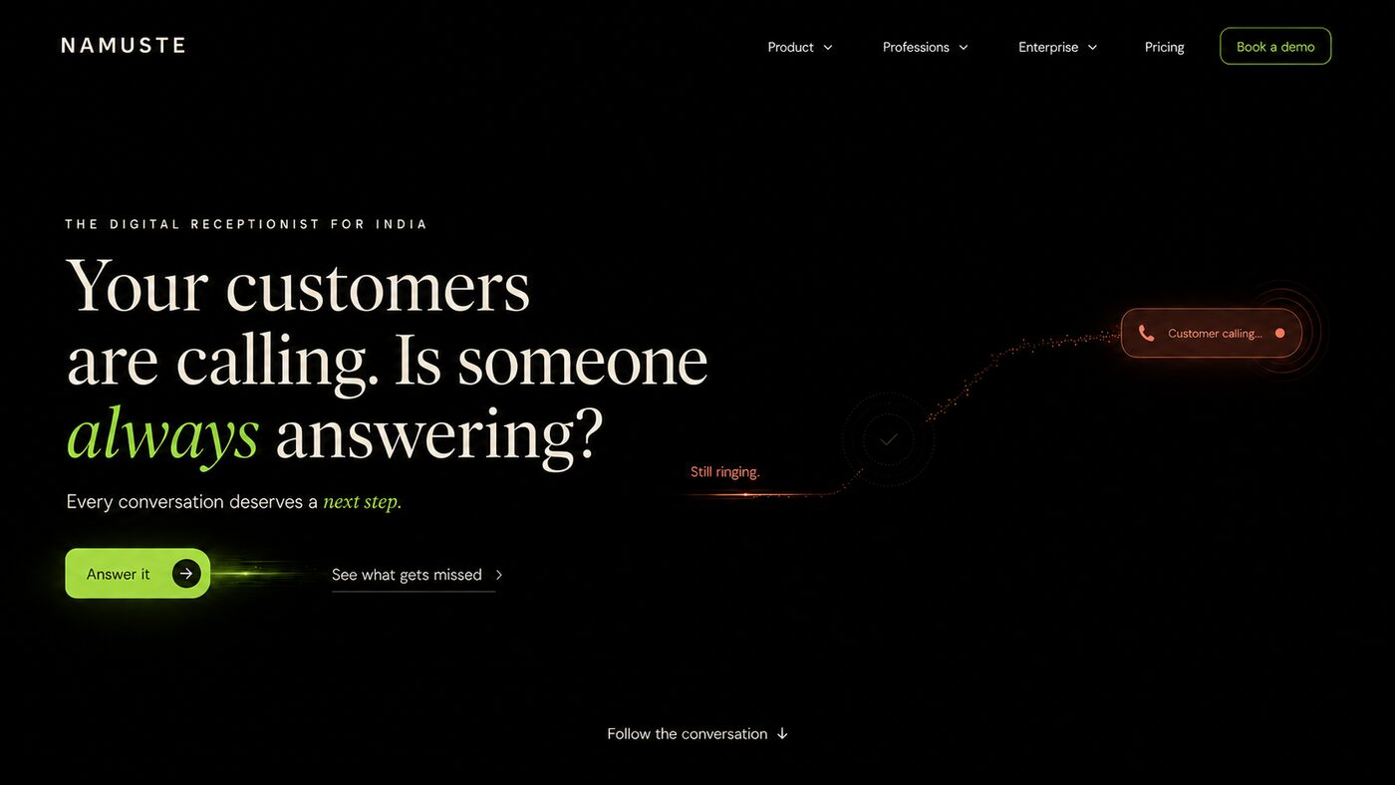
Approved visual direction: deep black, editorial ivory, restrained lime and coral, deliberate negative space.
Document field | Value
Owner | Namuste founding and growth team
Audience | Product, design, content, engineering, QA, SEO, analytics, legal and leadership
Status | Build-ready baseline
Version | 1.1 — profession and enterprise visual references added
Date | 20 August 2026
Source of truth | Namuste Website Builder Master Document and approved website decisions

PRODUCT STATEMENT Namuste is the Digital Receptionist for businesses that cannot afford to lose a customer conversation. It answers, understands, acts, follows up and creates a responsible next step across Voice, WhatsApp and Web.

00 / DOCUMENT CONTROL

How to use this PRD
This PRD defines the public website as a product: what it must communicate, how it must behave, what data it needs, how success will be measured and what constitutes a releasable implementation.
Role | Primary responsibility
Business owner | Approve positioning, claims, commercial model and launch scope.
Product owner | Own requirements, priorities, dependencies and decisions.
Design | Translate requirements into responsive UI while protecting the approved brand system.
Content | Deliver exact copy, industry examples, proof and policy content.
Frontend | Build accessible interactions, state handling, analytics hooks and performance.
Backend/CMS | Provide content models, demo orchestration, form handling, integrations and auditability.
QA | Verify functional, responsive, content, accessibility, analytics and operational acceptance.
Legal/Security | Approve privacy, consent, claims, data processing and trust content.

Requirement language
- MUST means mandatory for the stated release. SHOULD means strongly preferred and may be deferred only through a documented product decision. MAY means optional.
- Each requirement has a stable ID. Jira, Linear or any delivery tracker should preserve the ID so design, code and QA remain traceable.
- Where a visual mock-up conflicts with written requirements, this PRD controls behaviour and the mock-up controls art direction only.
SCOPE BOUNDARY This PRD covers the public marketing website and its embedded demonstrations. It does not define the authenticated Digital Receptionist operating product, except where a product screen is referenced as a future demo or proof surface.

01 / PRODUCT FOUNDATION

Vision, problem and category
The website must make an invisible response failure commercially visible, establish Digital Receptionist as a distinct category and let visitors experience a controlled next step before asking them to buy.

Problem statement
Businesses invest in generating demand, but customer conversations are lost between interest and action: calls go unanswered, messages remain unread, enquiries are misunderstood, follow-ups lapse and exceptions have no owner.

Website product hypothesis
HYPOTHESIS If a visitor recognises the response problem, sees how Namuste turns one conversation into a responsible outcome, and can try that mechanism using a familiar profession or enterprise context, then the visitor will understand the category and be more likely to start a qualified demo conversation.

Positioning hierarchy
Layer | Approved direction | Avoid
Category | Digital Receptionist | AI front desk, chatbot, generic AI assistant
Promise | Every conversation gets a next step. | Unverifiable replacement or revenue guarantees
Mechanism | Answer → Understand → Act → Follow up → Learn | Model names, technical novelty as the lead
Channels | Voice, WhatsApp and Web | Channel-specific silos
Market stance | Industry agnostic; Doctors & Clinics first in priority | Healthcare-only identity or undifferentiated “for everyone” language
Trust stance | Approved knowledge, boundaries and human handoff | Autonomous “knows everything” claims

Product principles
- Problem before product.
- Conversation before interface.
- Outcome before capability.
- Category before underlying technology.
- One strong interaction per viewport.
- Show breadth through selectable states, not stacked repetitive pages.
- Demonstrate judgment and boundaries, not merely fluency.
- Preserve approximately 70% negative space in principal marketing compositions.
- Doctors & Clinics receive precedence without confining the category.
02 / GOALS

Goals, non-goals and measurable outcomes
The website must be judged by category understanding, qualified engagement and operational quality—not by decorative completeness.
Goal ID | Goal | Success signal
G-01 | Establish “Digital Receptionist” as Namuste’s category. | Visitors can accurately describe Namuste after the hero and operating-loop sections.
G-02 | Make response loss personally and commercially recognisable. | High continuation from hero into problem and operating loop.
G-03 | Prove relevance across professions and enterprise types. | Meaningful selector usage beyond the default state.
G-04 | Demonstrate safe action, boundaries and human ownership. | Visitors engage with answer/clarify/handoff interactions.
G-05 | Turn interest into qualified conversations. | Completed real-conversation demos and demo bookings.
G-06 | Create a scalable content and landing-page system. | New profession/enterprise pages can be published without bespoke code.

Explicit non-goals
- Recreating the authenticated product dashboard on the homepage.
- Publishing every exploratory screen as a marketing section.
- Selling Namuste as a replacement for all staff.
- Claiming medical, legal, financial or other professional judgment.
- Listing model providers or “AI features” as the principal differentiation.
- Launching a full self-service product onboarding flow inside the public website.
- Showing unsupported metrics as customer proof.
- Building separate frontends for every industry.

North-star and supporting metrics
Metric | Definition | Initial interpretation
Qualified Experience Rate | Unique visitors completing a demo result or booking a demo ÷ eligible unique visitors. | Primary website product metric.
Problem Recognition Rate | Visitors reaching the operating loop after viewing the problem sequence. | Measures narrative relevance.
Explorer Engagement | Visitors selecting a non-default profession or enterprise and a channel. | Measures breadth comprehension.
Demo Start Rate | Visitors who start “Bring one real conversation.” | Measures product curiosity.
Demo Completion Rate | Demo starts reaching a result with an available next action. | Measures usability and credibility.
Qualified Lead Rate | Submissions meeting agreed role/company/use-case criteria. | Commercial quality, not raw volume.
Core Web Vitals Pass Rate | 75th percentile field performance passing defined targets. | Experience quality.
Accessibility Escape Rate | Critical flows completable with keyboard and assistive technology. | Inclusive operability.

03 / USERS

Audience segments and jobs to be done
The website must adapt its proof without fragmenting the category.
Audience | Primary job | Anxiety | Required website response
Independent professional | Capture enquiries without interrupting core work. | Will it sound credible and know its limits? | Profession-specific conversation, channels, boundaries and simple start.
Practice or small business owner | Create consistent reception across staff and hours. | Will it integrate, hand over and reduce repetitive work? | Shared workflows, actions, handoffs and proof.
Enterprise operator | Standardise reception across locations/departments. | Governance, configuration, rollout and escalation. | Enterprise topology, local controls, audit and deployment model.
Functional buyer | Evaluate fit, security, implementation and economics. | Risk, ownership, integration and measurable value. | Product, trust, pricing and implementation details.
Partner/investor/talent | Understand category, market breadth and conviction. | Is this distinct, credible and scalable? | Clear category narrative and evidence without cluttering conversion flow.

Priority profession order
- Doctors & Clinics — priority #1 and first navigation/explorer/SEO rollout.
- Lawyers.
- Chartered Accountants.
- Consultants.
- Architects.
- Real Estate professionals.
- Education professionals and institutions.
- Distributors.

Priority enterprise order
- Healthcare Networks; Retail Chains; Financial Services; Logistics; Education Groups; Manufacturing; Agri Enterprises; Conglomerates.
04 / SCOPE

Release scope and phased delivery
The first release must tell the complete story and create a working conversion path; breadth pages can follow through the same templates.
Phase | Included | Exit condition
P0 — Foundation | Content lock, category language, design tokens, CMS schema, analytics plan, legal review. | Approved copy/claim register and component contracts.
P1 — Homepage MVP | Global shell and 14 homepage sections; profession and enterprise explorers; lead forms. | Responsive, accessible, instrumented and CMS-driven.
P2 — Priority pages | Product, Doctors & Clinics, Lawyers, Distributors, Healthcare Networks, Enterprise, Pricing, Trust. | SEO-ready and demo-linked.
P3 — Breadth | Remaining profession/enterprise pages, integrations, resources, FAQ and company pages. | Template publishing workflow proven.
P4 — Demonstration depth | Real-conversation demo orchestration, optional voice mode, richer outcomes. | Consent, retention, safety and qualification verified.
P5 — Optimisation | Experiments, case studies, proof, localisation and performance refinements. | Measured improvement without brand dilution.

Out-of-scope product screens retained for future product/app use
- Role-definition wizard
- Approved-truth setup
- Promise and boundary setup
- Role charter
- Private rehearsal room
- First live shift
- Morning handover / shift review
- Overflow and replacement logic
- Full operating dashboard and conversation history
05 / INFORMATION ARCHITECTURE

Routes, navigation and content hierarchy
Every route must have a clear communication job and a canonical relationship to the category—not exist merely because a mock-up was produced.
Level 1 | Routes | Purpose
Home | / | Problem, category, mechanisms, breadth, trust, proof, experience and conversion.
Product | /product, /voice, /whatsapp, /web, /knowledge, /handoffs, /integrations, /insights | Explain the operating system of the Digital Receptionist.
Professions | /professions plus one route per profession | Template-led profession relevance and journeys.
Enterprise | /enterprise plus one route per enterprise type | Topology, governance, rollout and proof for complex organisations.
Pricing | /pricing | Complexity-based packaging and qualification.
Trust | /trust, /privacy, /security | Data, consent, retention, access, audit and human review.
Resources | /resources, /guides, /case-studies, /faq | Education, proof and discovery.
Company | /about, /contact, /careers | Origin, conviction, team and contact.
Legal | /terms, /privacy-policy, /cookie-policy | Mandatory policy surfaces.

IA-001 Global desktop navigation
Provide a persistent, restrained navigation with the NAMUSTE wordmark, Product, Professions, Enterprise, Pricing, optional Resources and “Book a demo”.
Priority: MUST

Acceptance criteria
- Logo returns to home without opening a new tab.
- All dropdown items are keyboard reachable and close on Escape.
- Doctors & Clinics appears first under Professions; Healthcare Networks first under Enterprise.
- Active route is conveyed by more than colour alone.
IA-002 Mobile navigation
Use a compact menu and preserve one conversion action without reproducing the full desktop navigation.
Priority: MUST

Acceptance criteria
- Menu traps no keyboard focus and restores focus to its trigger on close.
- Body scroll is controlled while open.
- All first-level destinations remain reachable in two taps or fewer.
IA-003 Footer
Provide category statement, grouped navigation, trust/legal links, contact route and final CTA.
Priority: MUST

Acceptance criteria
- No duplicate conflicting CTA language.
- Policy links remain available without JavaScript.
- Footer content is CMS-managed except mandatory system routes.
06 / GLOBAL EXPERIENCE

Design, content and interaction system
The visual experience must feel premium because of restraint, typography and intentional motion—not because every surface is animated.

Visual tokens
Token | Requirement | Use
Canvas | Near-black #050605 / calibrated OLED black | Primary marketing sections.
Primary text | Warm ivory #F2EEE6 | Editorial headlines and core statements.
Action | Electric lime #8FD813–#9BEA16 | Selected state, approved action, completion and CTA.
Unresolved | Coral #FF7359 | Missed, blocked, urgent or unresolved states only.
Editorial type | Premium high-contrast serif | Emotional/problem headlines and italic emphasis.
Interface type | Neutral modern grotesk/sans | Navigation, UI, labels, controls and body.
Negative space | Target 65–75% per principal viewport | Protect focus; not an absolute pixel calculation.
Imagery | Ultra-high-resolution, cinematic, authentic Indian environments | Profession/enterprise context, never generic AI imagery.

Prohibited visual patterns
- Robots, glowing brains, holographic faces or synthetic AI clichés.
- Stock call-centre headsets as the category image.
- Crowded SaaS dashboards in the first two homepage acts.
- Persistent neon glows, gradients or animated particles with no narrative function.
- Industry stereotypes, fake uniforms or visually misleading professional scenes.
- Lime used decoratively where it no longer signals selection or resolved action.
GX-001 Motion system
Use motion to explain state change, not to decorate empty space.
Priority: MUST

Acceptance criteria
- Essential content and controls are visible without waiting for animation.
- Reduced-motion mode removes path drawing, parallax, pulsing and autoplay transitions while preserving meaning.
- Principal transitions complete in approximately 300–600 ms; long narrative paths may extend to 900 ms once.
- No scroll-jacking.
GX-002 Content terminology guardrail
Use “Digital Receptionist” as the public category and describe AI only as enabling intelligence when technically or contextually necessary.
Priority: MUST

Acceptance criteria
- No primary headline or navigation label says AI Front Desk.
- No claim implies professional advice, diagnosis, legal opinion, financial recommendation or autonomous authority.
- “Learn” is explained as approved improvement, not uncontrolled model training.
GX-003 UI state semantics
Every interactive state must have selected, available, unavailable, loading, success, empty and error semantics where applicable.
Priority: MUST

Acceptance criteria
- Selected state is communicated with text/icon/border in addition to colour.
- Unavailable states explain why and provide an alternative.
- Error states preserve user input and offer recovery.
07 / HOMEPAGE

Homepage narrative and section contract
The homepage is a guided conversation in five acts. It may be visually long, but it must remain conceptually disciplined and contain no more than fourteen essential sections.
Act | Sections | Communication job
I — The loss | 01–02 | Make the response problem visible and commercially urgent.
II — The category | 03–05 | Define Digital Receptionist and prove breadth.
III — Why it works | 06–10 | Show systems, language, judgment, handoffs and manner.
IV — Proof | 11–12 | Translate conversations into measurable value.
V — Experience | 13–14 | Let the visitor bring a real conversation and convert.

HP-01 / HOMEPAGE

Problem-led hero
Your customers are calling. Is someone always answering?
Directional reference for Problem-led hero.

Approved content contract
Eyebrow: THE DIGITAL RECEPTIONIST FOR INDIA
Headline: Your customers are calling. Is someone always answering?
Supporting content: Every conversation deserves a next step.
Primary CTA: Experience Namuste
Secondary CTA: See what gets missed

Display requirements
- One unresolved coral conversation trajectory moves toward a quiet lime resolution point.
- No human photo, robot or dashboard in the first viewport.
- One semantic H1; primary content visible without animation.

Behaviour and acceptance
- Primary CTA anchors to HP-13.
- Secondary CTA anchors to HP-02.
- Track CTA, scroll continuation and viewport completion.

Responsive contract
- Desktop may use the approved asymmetric composition; mobile must preserve reading order, selected state and primary action without horizontal overflow.
- All controls are keyboard operable, labelled and meaningful without motion or hover.

Analytics
- Emit section_view with section_id=HP-01; emit component-specific selection and CTA events defined in the analytics taxonomy.
HP-02 / HOMEPAGE

The response problem
The business did not respond.
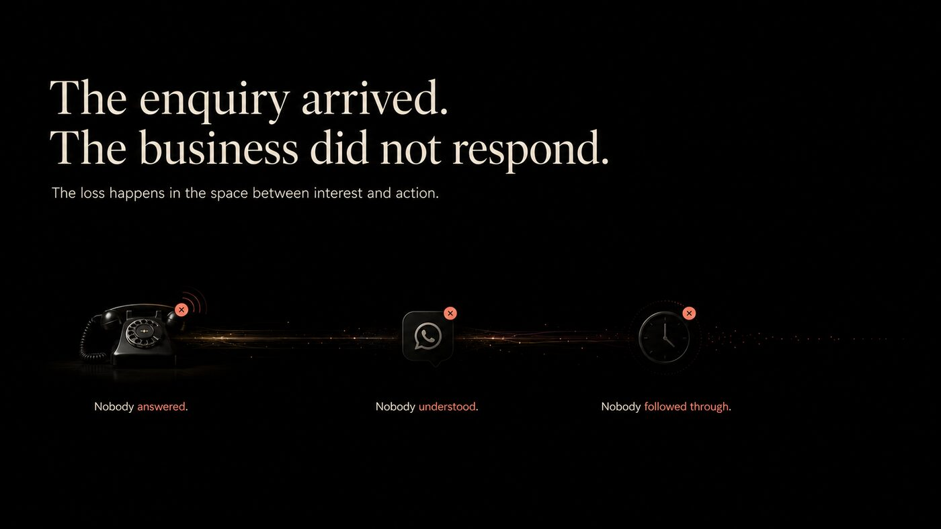
Directional reference for The response problem.

Approved content contract
Eyebrow: THE ENQUIRY ARRIVED.
Headline: The business did not respond.
Supporting content: The loss happens in the space between interest and action.

Display requirements
- Show Nobody answered, Nobody understood and Nobody followed through as universal loss states.
- Hover/focus may reveal one consequence per state.
- Mobile changes horizontal progression into a vertical sequence.

Behaviour and acceptance
- Final unresolved point becomes the start of HP-03.
- Track each state exposure, not only hover.

Responsive contract
- Desktop may use the approved asymmetric composition; mobile must preserve reading order, selected state and primary action without horizontal overflow.
- All controls are keyboard operable, labelled and meaningful without motion or hover.

Analytics
- Emit section_view with section_id=HP-02; emit component-specific selection and CTA events defined in the analytics taxonomy.
HP-03 / HOMEPAGE

Operating loop
From hello to an outcome.
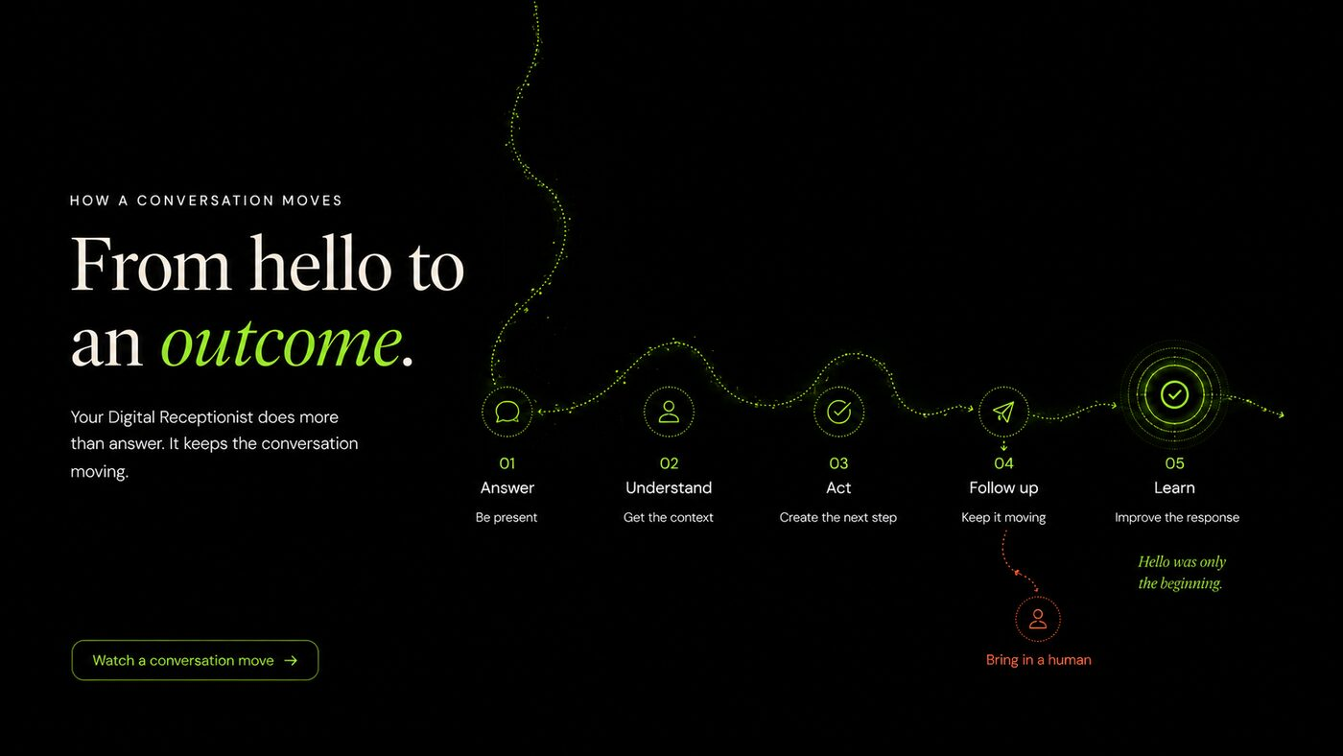
Directional reference for Operating loop.

Approved content contract
Eyebrow: HOW A CONVERSATION MOVES
Headline: From hello to an outcome.
Supporting content: Answer · Understand · Act · Follow up · Learn

Display requirements
- Use one continuous line with five accessible points.
- Channels: Voice, WhatsApp and Web.
- Each point reveals one practical example; “Learn” means team-approved improvement.

Behaviour and acceptance
- Channel choice changes example, not the operating model.
- Expose a text alternative to the visual path.

Responsive contract
- Desktop may use the approved asymmetric composition; mobile must preserve reading order, selected state and primary action without horizontal overflow.
- All controls are keyboard operable, labelled and meaningful without motion or hover.

Analytics
- Emit section_view with section_id=HP-03; emit component-specific selection and CTA events defined in the analytics taxonomy.
HP-04 / HOMEPAGE

Professions explorer
Different professions. The same need for a next step.
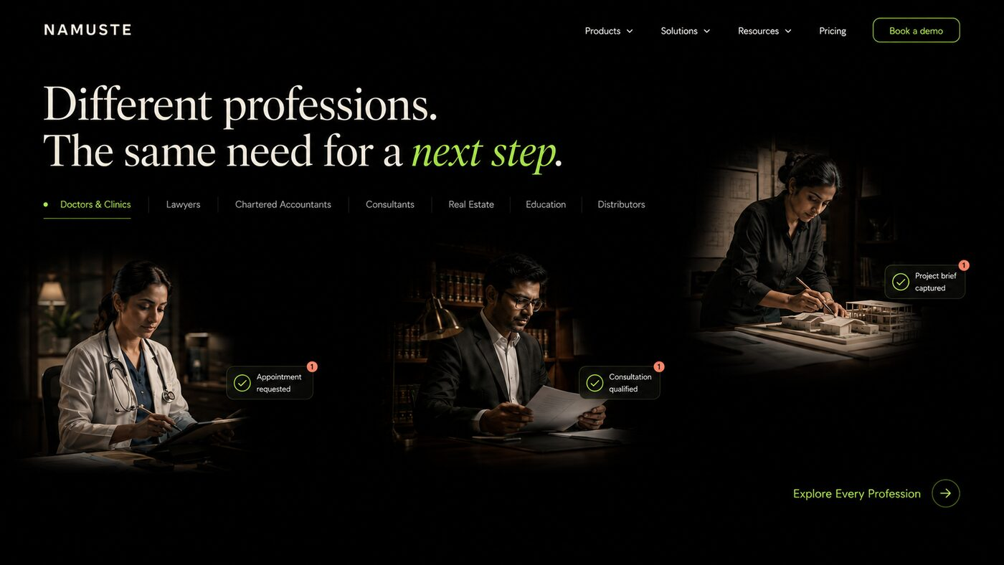
Directional reference for Professions explorer.

Approved content contract
Eyebrow: ONE ROLE. MANY PROFESSIONS.
Headline: Different professions. The same need for a next step.
Supporting content: Doctors & Clinics first; then Lawyers, Chartered Accountants, Consultants, Architects, Real Estate, Education and Distributors.
Primary CTA: Give Namuste a profession

Display requirements
- One selected profession at a time; relevant cinematic image and conversation outcome.
- Selected profession uses lime; inactive labels remain ivory.
- Channel selector MUST appear directly below the selected profession control.

Behaviour and acceptance
- Tabs use correct ARIA semantics and keyboard arrows.
- Profession and channel states have stable URL fragments.
- CTA deep-links to selected profession page.

Responsive contract
- Desktop may use the approved asymmetric composition; mobile must preserve reading order, selected state and primary action without horizontal overflow.
- All controls are keyboard operable, labelled and meaningful without motion or hover.

Analytics
- Emit section_view with section_id=HP-04; emit component-specific selection and CTA events defined in the analytics taxonomy.
HP-05 / HOMEPAGE

Enterprise explorer
Different enterprises. The same need to never lose a conversation.
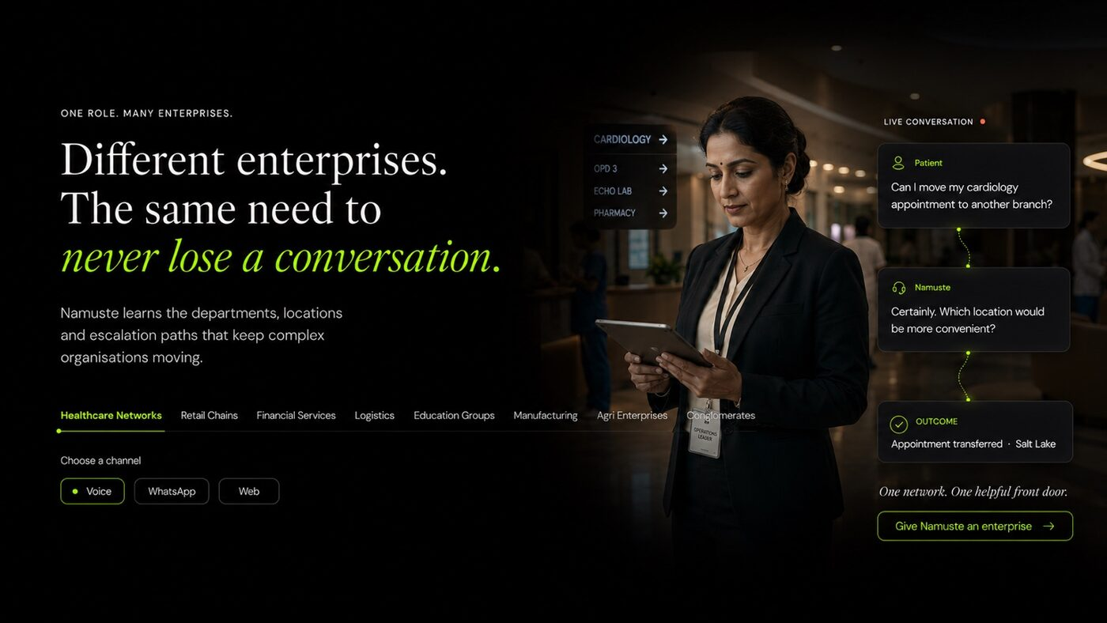
Directional reference for Enterprise explorer.

Approved content contract
Eyebrow: ONE ROLE. MANY ENTERPRISES.
Headline: Different enterprises. The same need to never lose a conversation.
Supporting content: Healthcare Networks, Retail Chains, Financial Services, Logistics, Education Groups, Manufacturing, Agri Enterprises and Conglomerates.
Primary CTA: Give Namuste an enterprise

Display requirements
- Selected state shows department, location, escalation and outcome context.
- Healthcare Networks first but not exclusive.
- Use operational environments, not boardroom stock imagery.

Behaviour and acceptance
- Channel selector sits beneath the enterprise selector.
- CTA links to selected enterprise page.

Responsive contract
- Desktop may use the approved asymmetric composition; mobile must preserve reading order, selected state and primary action without horizontal overflow.
- All controls are keyboard operable, labelled and meaningful without motion or hover.

Analytics
- Emit section_view with section_id=HP-05; emit component-specific selection and CTA events defined in the analytics taxonomy.
HP-06 / HOMEPAGE

One conversation layer
Your business already has systems. Namuste makes conversations work with them.
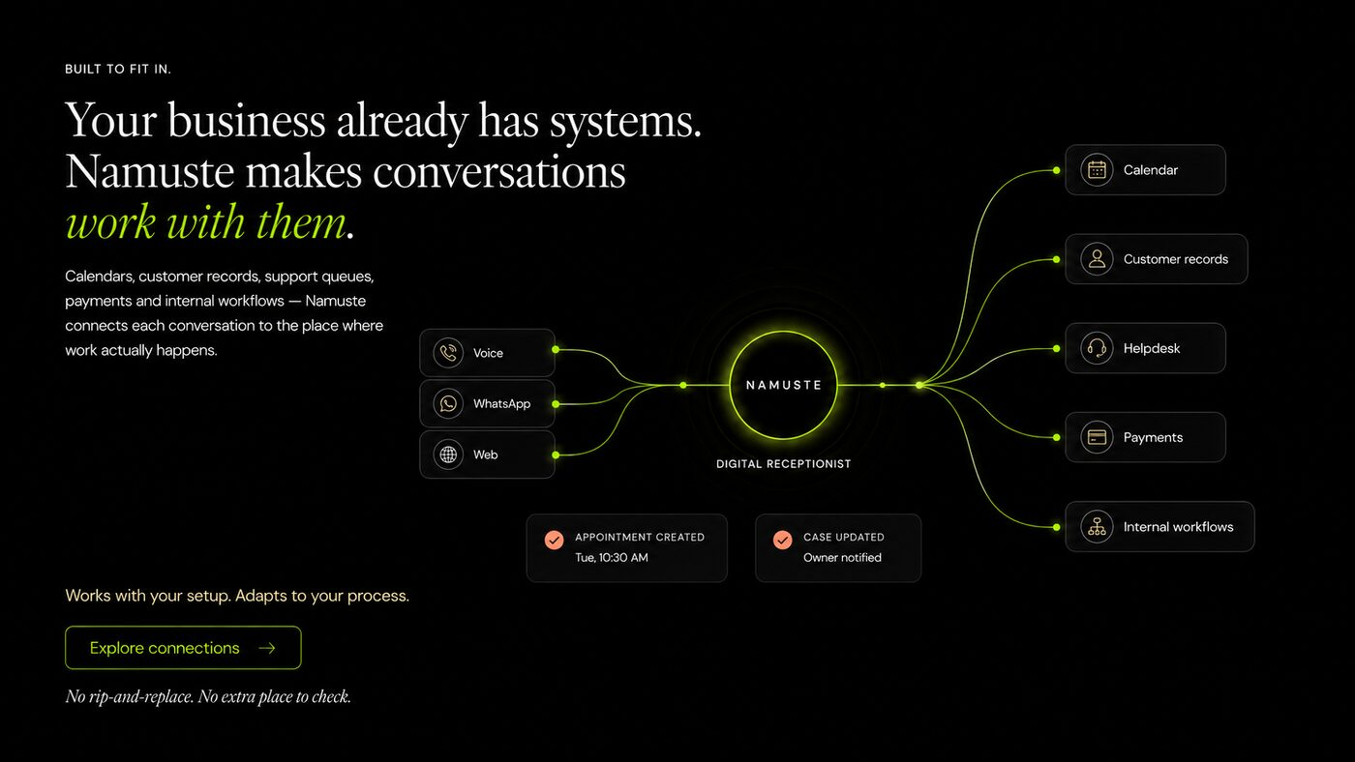
Directional reference for One conversation layer.

Approved content contract
Headline: Your business already has systems. Namuste makes conversations work with them.
Supporting content: Voice, WhatsApp and Web connect with calendars, CRM, helpdesk, payments and internal workflows.
Primary CTA: Explore integrations

Display requirements
- Namuste is a small connection point—not a giant technology brain.
- Show no more than five relevant systems simultaneously.
- Use logos only with permission.

Behaviour and acceptance
- Expandable examples; link to /integrations.
- Mobile uses a simple input → Namuste → outcome path.

Responsive contract
- Desktop may use the approved asymmetric composition; mobile must preserve reading order, selected state and primary action without horizontal overflow.
- All controls are keyboard operable, labelled and meaningful without motion or hover.

Analytics
- Emit section_view with section_id=HP-06; emit component-specific selection and CTA events defined in the analytics taxonomy.
HP-07 / HOMEPAGE

Multilingual continuity
Your customers will not always speak in one language. Neither should your receptionist.
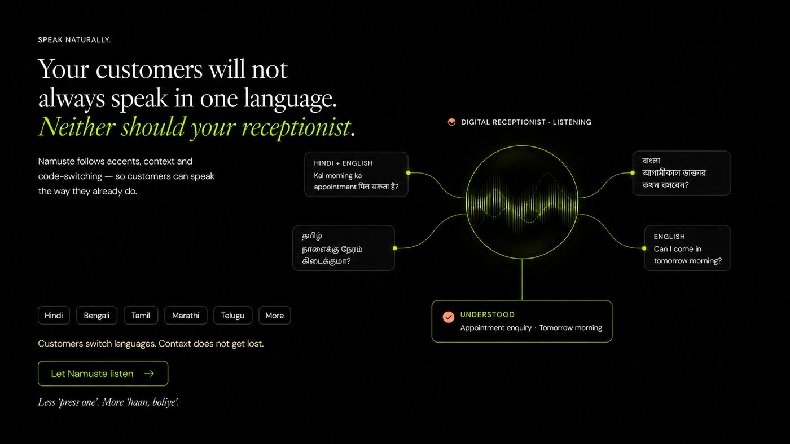
Directional reference for Multilingual continuity.

Approved content contract
Headline: Your customers will not always speak in one language. Neither should your receptionist.
Supporting content: Namuste follows the customer’s language and preserves context across the switch.

Display requirements
- Show one continuing conversation, not a flags grid.
- Language availability and beta status are CMS controlled.
- Use correct native scripts and fonts.

Behaviour and acceptance
- Language choice updates the same example.
- Never imply every displayed language is production ready.

Responsive contract
- Desktop may use the approved asymmetric composition; mobile must preserve reading order, selected state and primary action without horizontal overflow.
- All controls are keyboard operable, labelled and meaningful without motion or hover.

Analytics
- Emit section_view with section_id=HP-07; emit component-specific selection and CTA events defined in the analytics taxonomy.
HP-08 / HOMEPAGE

Approved answers and judgment
A confident wrong answer is still wrong. Namuste knows when to ask.
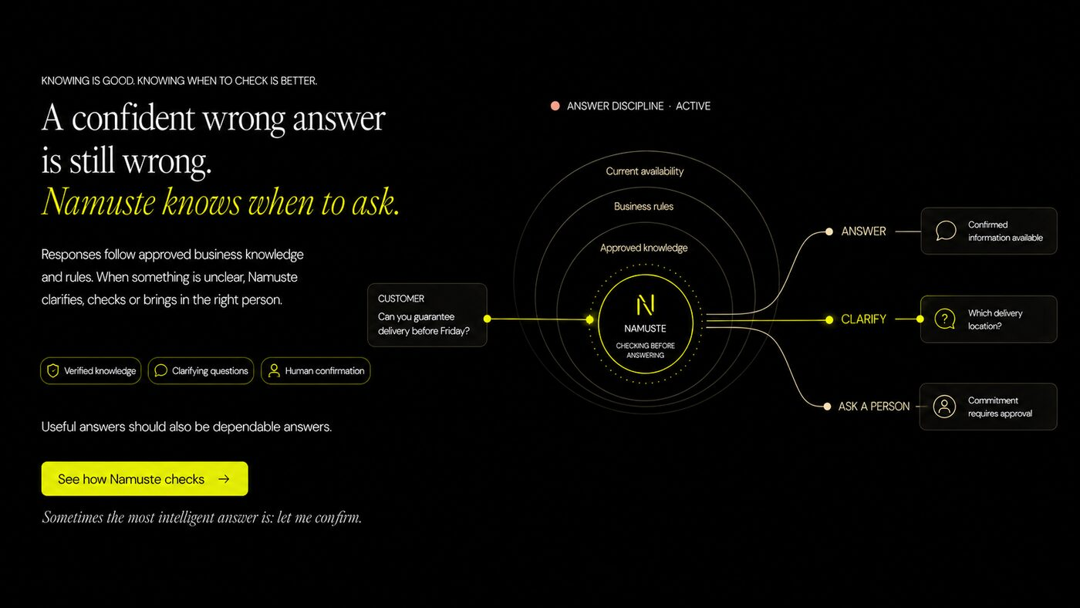
Directional reference for Approved answers and judgment.

Approved content contract
Headline: A confident wrong answer is still wrong. Namuste knows when to ask.
Supporting content: Answer · Clarify · Ask a person
Primary CTA: See how Namuste decides

Display requirements
- A small decision point branches into three paths.
- Lime marks approved action; coral marks uncertainty or blocked promise.
- Each path displays approved source/rule and example.

Behaviour and acceptance
- Link to /knowledge and /trust.
- Track path selection and CTA.

Responsive contract
- Desktop may use the approved asymmetric composition; mobile must preserve reading order, selected state and primary action without horizontal overflow.
- All controls are keyboard operable, labelled and meaningful without motion or hover.

Analytics
- Emit section_view with section_id=HP-08; emit component-specific selection and CTA events defined in the analytics taxonomy.
HP-09 / HOMEPAGE

Human handoff
Some conversations need a person. Namuste knows which ones.
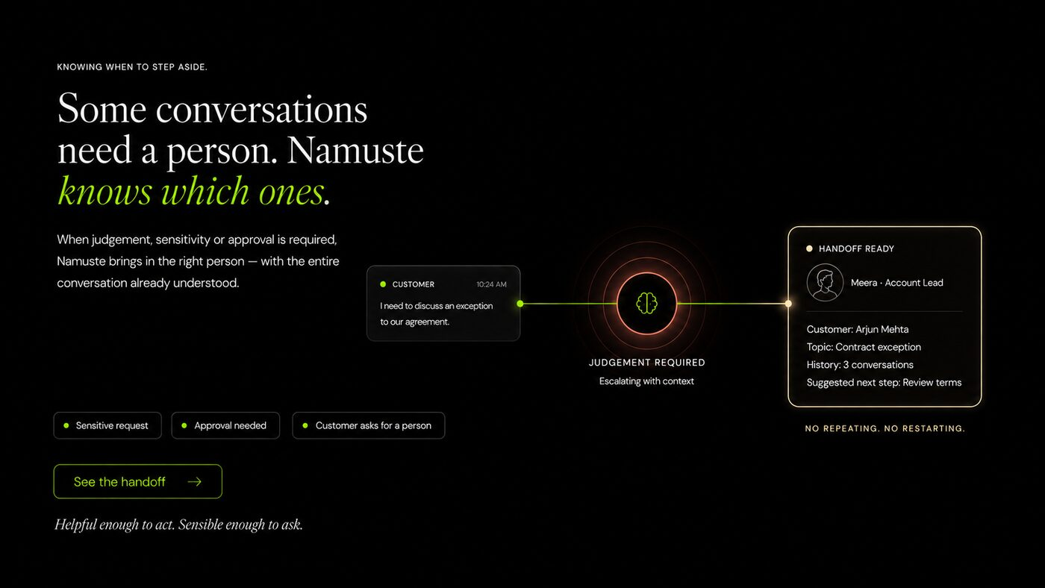
Directional reference for Human handoff.

Approved content contract
Headline: Some conversations need a person. Namuste knows which ones.
Supporting content: Context, urgency, owner and promised response time travel together.
Primary CTA: See the handoff

Display requirements
- Show one handoff packet, not an operations queue.
- Examples: urgent request, commercial exception, sensitive situation.

Behaviour and acceptance
- Example selector changes the packet and responsible owner.
- Customer-facing content must not reveal internal complexity.

Responsive contract
- Desktop may use the approved asymmetric composition; mobile must preserve reading order, selected state and primary action without horizontal overflow.
- All controls are keyboard operable, labelled and meaningful without motion or hover.

Analytics
- Emit section_view with section_id=HP-09; emit component-specific selection and CTA events defined in the analytics taxonomy.
HP-10 / HOMEPAGE

Business-specific manner
People remember how a business makes them feel. Namuste learns how yours should sound.
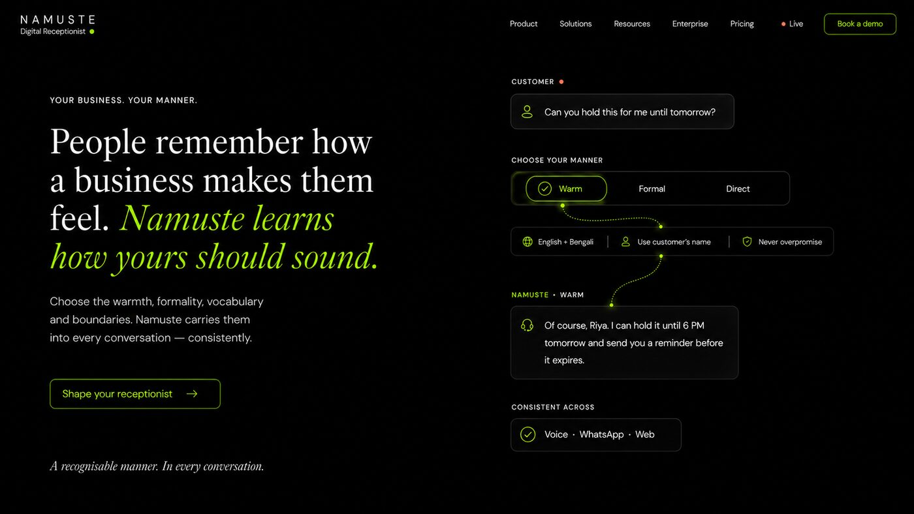
Directional reference for Business-specific manner.

Approved content contract
Eyebrow: YOUR BUSINESS. YOUR MANNER.
Headline: People remember how a business makes them feel. Namuste learns how yours should sound.
Supporting content: Warm · Formal · Direct

Display requirements
- Demonstrate one answer in three manners.
- Never overpromise; preserve the same factual content.
- No voice avatars.

Behaviour and acceptance
- Tone choice is session-only and does not claim to change a live assistant.

Responsive contract
- Desktop may use the approved asymmetric composition; mobile must preserve reading order, selected state and primary action without horizontal overflow.
- All controls are keyboard operable, labelled and meaningful without motion or hover.

Analytics
- Emit section_view with section_id=HP-10; emit component-specific selection and CTA events defined in the analytics taxonomy.
HP-11 / HOMEPAGE

Messy conversations
People pause. Interrupt. Change their mind. Namuste simply keeps up.

Approved content contract
Eyebrow: CONVERSATIONS DO NOT READ SCRIPTS.
Headline: People pause. Interrupt. Change their mind. Namuste simply keeps up.
Supporting content: Show interruption, correction and changed intent.

Display requirements
- Use one conversation playback with visible transcript changes.
- Do not autoplay audio.
- Corrections must remain understandable without colour.

Behaviour and acceptance
- Provide play/pause, transcript and reduced-motion alternative.

Responsive contract
- Desktop may use the approved asymmetric composition; mobile must preserve reading order, selected state and primary action without horizontal overflow.
- All controls are keyboard operable, labelled and meaningful without motion or hover.

Analytics
- Emit section_view with section_id=HP-11; emit component-specific selection and CTA events defined in the analytics taxonomy.
HP-12 / HOMEPAGE

Commercial proof
Some missed conversations disappear. Others take tomorrow’s revenue with them.

Approved content contract
Headline: Some missed conversations disappear. Others take tomorrow’s revenue with them.
Supporting content: Illustrative calculator: conversations/day, missed %, average outcome value.
Primary CTA: Calculate the cost

Display requirements
- Clearly label estimates as illustrative.
- No guaranteed revenue claim.
- Use local currency formatting and guard against unrealistic inputs.

Behaviour and acceptance
- Recalculate locally; validate all fields; provide assumptions.
- Track start, completion and CTA without sending sensitive inputs to advertising platforms.

Responsive contract
- Desktop may use the approved asymmetric composition; mobile must preserve reading order, selected state and primary action without horizontal overflow.
- All controls are keyboard operable, labelled and meaningful without motion or hover.

Analytics
- Emit section_view with section_id=HP-12; emit component-specific selection and CTA events defined in the analytics taxonomy.
HP-13 / HOMEPAGE

Bring one real conversation
Bring us the conversation your business keeps missing.

Approved content contract
Eyebrow: DO NOT BOOK A DEMONSTRATION.
Headline: Bring us the conversation your business keeps missing.
Supporting content: Choose profession and channel; enter or select a real question.
Primary CTA: Let Namuste answer
Secondary CTA: Book a demo

Display requirements
- Progressively disclose fields; never open with a large form.
- Explain whether demo text is stored and for how long.
- Profession selection reveals channel directly below.

Behaviour and acceptance
- Support scripted examples plus controlled free text.
- Moderate unsafe/unsupported inputs and provide an alternative.
- Track consent, start, completion and result.

Responsive contract
- Desktop may use the approved asymmetric composition; mobile must preserve reading order, selected state and primary action without horizontal overflow.
- All controls are keyboard operable, labelled and meaningful without motion or hover.

Analytics
- Emit section_view with section_id=HP-13; emit component-specific selection and CTA events defined in the analytics taxonomy.
HP-14 / HOMEPAGE

Demonstration result
A question about stock becomes a qualified opportunity.

Approved content contract
Headline: A question about stock becomes a qualified opportunity.
Supporting content: Show Answer → Understand → Act; include answer, qualification, action and owner.
Primary CTA: Book a working session
Secondary CTA: Try another conversation

Display requirements
- Result must feel like an outcome, not a chat transcript.
- Display qualification and action only when supported by the selected demo scenario.

Behaviour and acceptance
- Preserve profession/channel across retry.
- If live generation fails, provide a deterministic example and transparent status.

Responsive contract
- Desktop may use the approved asymmetric composition; mobile must preserve reading order, selected state and primary action without horizontal overflow.
- All controls are keyboard operable, labelled and meaningful without motion or hover.

Analytics
- Emit section_view with section_id=HP-14; emit component-specific selection and CTA events defined in the analytics taxonomy.
08 / EXPLORERS

Profession and enterprise state engine
The explorer components are the main proof of industry breadth. They must be data-driven, deep-linkable, accessible and reusable on homepage and hub pages.
EXP-001 Profession selection
Selecting a profession updates the hero image, customer language, example enquiry, response, outcome, boundary and CTA without navigating away.
Priority: MUST

Acceptance criteria
- Doctors & Clinics is the default and first item.
- Changing profession never silently changes the selected channel.
- The URL fragment updates without adding excessive browser history entries.
- Reloading a valid fragment restores state.
EXP-002 Channel placement
Reveal “Choose a channel” directly beneath the selected profession or enterprise control.
Priority: MUST

Acceptance criteria
- Voice, WhatsApp and Web appear in that order unless availability rules say otherwise.
- No channel chooser appears in a disconnected column or below the entire section.
- Changing channel updates the example while preserving profession/enterprise selection.
EXP-003 Content completeness
Do not publish a selectable state until its required content fields are complete.
Priority: MUST

Acceptance criteria
- Required: name, slug, priority, hero asset, problem, example question, Namuste response, outcome, action, boundary, available channels, CTA route and SEO data.
- CMS blocks publication when required fields are missing.

Profession state matrix
Profession | Priority conversations | Typical action | Boundary
Doctors & Clinics | Appointments, preparation, reports, rescheduling, location/speciality routing. | Book/reschedule, route symptoms, share approved instructions, follow up. | No diagnosis, treatment recommendation or emergency substitution.
Lawyers | Consultation intake, matter type, documents, appointment. | Qualify, book, collect context, assign lawyer. | No legal advice or outcome promise.
Chartered Accountants | Filing status, document checklist, appointment, deadline. | Collect missing documents, schedule, route by service. | No tax position or statutory commitment without approval.
Consultants | Discovery, fit, availability, proposal follow-up. | Qualify, schedule, remind, route. | No scope, price or result guarantee outside approved offer.
Architects | Project fit, site, budget band, consultation. | Collect brief, qualify and schedule. | No structural or regulatory commitment.
Real Estate | Property enquiry, location, visit, financing query. | Qualify, schedule visit, assign advisor. | No availability, return or legal-title guarantee.
Education | Admissions, eligibility, fees, counselling, schedules. | Qualify, recommend approved programme, book counselling. | No admission or scholarship guarantee.
Distributors | Stock, territory, quantity, order status, service. | Qualify, check/route availability, assign territory owner. | No special price or unpublished stock commitment.

Enterprise state matrix
Type | Topology to demonstrate | Example outcome
Healthcare Networks | Locations, specialities, appointments, pharmacy, reports and transfer rules. | Appointment transferred to the preferred branch.
Retail Chains | SKU, store, inventory, order channel and service escalation. | Stock located and customer directed.
Financial Services | Product, eligibility, service queue, approved disclosures and risk. | Qualified enquiry routed to approved advisor.
Logistics | Shipment status, pickup, exception, proof and account owner. | Exception routed with promised update time.
Education Groups | Programme, campus, city, intake and counsellor. | Counsellor assigned and appointment booked.
Manufacturing | Dealer enquiry, product, quotation, service, geography and quantity. | Qualified enquiry assigned.
Agri Enterprises | Product, crop/geography, programme, retailer/farmer support and campaign. | Approved guidance or expert handoff.
Conglomerates | Multiple companies/brands, business unit, geography and department. | Conversation reaches the right operating company.

09 / PROFESSION PAGES

Profession landing-page template
Every profession page uses one stable system while replacing the customer problem, vocabulary, actions, boundaries, systems and proof.
Section | Required content
Hero | Profession-specific problem and outcome-led CTA.
Live example | One profession-native enquiry; channel selected beneath profession context.
What Namuste handles | Four to six high-value conversation categories.
What it can do | Bookings, qualification, updates, documents, routing or reminders as appropriate.
Boundaries | Explicit statements about what Namuste will not advise, diagnose, promise or approve.
Handoff | Owner, context packet and expected response.
Channels | Voice, WhatsApp and Web availability.
Systems | Calendar, CRM, case management, LMS or relevant systems.
Complete journey | Customer question to confirmed next step.
Proof/FAQ | Verified proof and profession-specific objections.
CTA | Experience selected assistant / Bring one real conversation.

PRO-001 Template rendering
Render every profession page from shared components and structured content rather than a separate bespoke codebase.
Priority: MUST

Acceptance criteria
- Template supports unique hero, content order overrides and relevant components.
- Shared fixes propagate across all profession pages.
- Each page has a canonical URL and unique metadata.
PRO-002 Safety boundaries
Display profession-specific boundaries before or adjacent to the live demonstration.
Priority: MUST

Acceptance criteria
- Doctors: no diagnosis, prescription or emergency replacement.
- Lawyers: no legal advice or outcome promise.
- Financial/tax: no unapproved recommendation or statutory commitment.
- Boundary wording is versioned and reviewable in CMS.

Doctors & Clinics: priority page contract
PRIORITY WITHOUT CONFINEMENT Doctors & Clinics must be the first profession in navigation, SEO rollout and commercial examples. It must not become the homepage’s only identity.

- Hero: “Patients are calling. Your front desk is already busy.”
- Core journeys: new appointment, rescheduling, report availability, specialty/location routing, pre-visit preparation, reminders and follow-up.
- Safety: emergency language triggers approved escalation guidance; no diagnosis or treatment response.
- Inputs: speciality, location, calendar, doctor availability, clinic policies and approved FAQs.
- Outcomes: appointment requested/booked, patient prepared, question routed, owner assigned.
- CTA: Experience the Clinic Assistant; secondary Book a demo.
10 / ENTERPRISE PAGES

Enterprise landing-page template
Enterprise pages must move beyond “more conversations” into multi-location operation, governance, configuration, rollout and control.
Section | Required content
Enterprise hero | Complex organisation, one helpful front door.
Operating topology | Locations, departments, channels and escalation owners.
Central governance | Shared role templates, approved sources, versioning and audit.
Local configuration | Language, hours, services, people and exceptions by location.
Routing | Department, territory, urgency, customer type and ownership.
Integrations | CRM, helpdesk, booking, order, payment and workflow systems.
Rollout | Start with one outcome/location/channel; rehearse; measure; expand.
Measurement | Response, resolution, next-step completion, handoff quality.
Trust | Permissions, retention, consent, access and human review.
CTA | Design the enterprise reception layer.

ENT-001 Enterprise topology component
Represent a customer path across business unit, location, department and owner without exposing sensitive internal detail.
Priority: MUST

Acceptance criteria
- Topology is configurable from CMS.
- Mobile reduces the diagram to a readable ordered journey.
- Accessible text exposes the same path.
ENT-002 Governance proof
Show how a central team controls approved knowledge and boundaries while local teams maintain operational detail.
Priority: MUST

Acceptance criteria
- No unverified security/compliance certification appears.
- Every governance claim links to supporting trust content.
11 / PRODUCT PAGES

Product page framework
Product pages explain the stable operating capabilities of a Digital Receptionist without turning the category into a feature catalogue.
Page | Hero promise | Essential proof
Digital Receptionist | One role across every customer conversation. | Answer, understand, act, follow up, learn.
Voice | The call is unanswered. The customer is not. | Natural turn-taking, interruption, language, consent and handoff.
WhatsApp | Move from message to next step without leaving the channel. | Context, structured capture, confirmation and follow-up.
Web | Turn website traffic into qualified conversations. | Embedded experience, consent, qualification and booking.
Knowledge & Rules | A confident answer begins with approved sources. | Source permission, freshness, uncertainty and human fallback.
Handoffs | Some conversations need a person. | Context packet, owner, urgency and response time.
Integrations | Make conversations work with the systems already in place. | Read/write boundaries, permissions and outcomes.
Insights | Measure what happened because someone answered. | Resolution, next-step completion, recurring questions and gaps.

PDP-001 Capability narrative
Each product page must connect the capability to customer outcome, controlled mechanism, proof and next action.
Priority: MUST

Acceptance criteria
- Page begins with an outcome/problem, not a feature list.
- Every technical claim has a defined state: available, beta, planned or illustrative.
- CTA preserves referral context and selected channel where applicable.
12 / DEMONSTRATION

Interactive “bring one real conversation” experience
The embedded demonstration is the website’s product moment. It must feel specific and useful while remaining safe, deterministic enough to trust and transparent about data use.

Primary flow
Step | User action | System behaviour | Exit/error
1. Context | Choose Profession or Enterprise. | Load relevant channels, example prompts, rules and boundaries. | Unavailable state offers nearest supported context.
2. Channel | Choose Voice, WhatsApp or Web. | Adapt UI and example while preserving context. | Channel unavailable explains status.
3. Question | Select an example or enter a question. | Validate length, unsafe content and consent. | Preserve text and provide correction.
4. Answer | Submit. | Return controlled answer or clarification path. | Timeout falls back to deterministic example.
5. Understand | Provide one required qualifier if needed. | Update context; do not repeat known information. | Allow skip where not mandatory.
6. Act | Show a next step based on scenario. | Book, route, request, schedule or assign—illustrative unless connected. | Clearly label simulated action.
7. Result | Review answer, qualification, action and owner. | Offer retry or working session CTA. | Maintain profession/channel state.

DEM-001 Progressive disclosure
Show only the current decision and the minimum context required for the next step.
Priority: MUST

Acceptance criteria
- Profession selection precedes channel selection.
- Channel selector is immediately beneath the selected profession/enterprise.
- Free text is not requested until a safe context and channel are known.
DEM-002 Demo modes
Support deterministic examples for launch and an optional controlled live-generation mode behind a feature flag.
Priority: MUST

Acceptance criteria
- Deterministic mode is always available.
- Live mode has timeout, moderation, grounding and fallback.
- UI never misrepresents a simulated booking, stock check or handoff as a real transaction.
DEM-003 Voice demonstration
If Voice is enabled, request microphone access only after an explicit user action and provide an equivalent text path.
Priority: MUST

Acceptance criteria
- Permission denial does not block the demo.
- Transcript is visible and editable where appropriate.
- Audio never autoplays.
- Recording purpose, retention and deletion are disclosed before capture.
DEM-004 Input safety and privacy
Minimise collection and prevent visitors from submitting sensitive personal or professional data.
Priority: MUST

Acceptance criteria
- Prominent guidance asks visitors to remove names, phone numbers, medical details, account numbers and confidential matter information.
- Client-side and server-side checks detect common sensitive patterns.
- Consent state and retention rule are recorded.
- A deletion/contact route is provided when data is retained.
DEM-005 Qualification handoff
Conversion form after the result asks only for information needed to route the opportunity.
Priority: MUST

Acceptance criteria
- Name, work email/phone, organisation, profession/enterprise, preferred channel, use case and consent.
- Fields already known from the demo are prefilled but editable.
- Submission creates one lead record with source context, not duplicate records.
13 / PRICING

Pricing page requirements
Pricing must scale with operating complexity, not profession labels. Exact prices remain editable until commercial packaging is approved.
Plan | Best for | Structure | Required transparency
Profession | One professional or small practice. | Base subscription, included channels/usage and overage. | Included minutes/messages, setup, calendar and support.
Team | Multi-person service business. | Higher base, users/locations and usage. | Routing, roles, analytics, integrations and onboarding.
Enterprise | Networks, departments and complex governance. | Custom platform, deployment and usage. | Security, SLA, environments, integrations and governance.

PRI-001 Complexity-based packaging
Do not charge or describe tiers purely by profession label.
Priority: MUST

Acceptance criteria
- Pricing dimensions can include channels, volume, locations, users, integrations, languages, support and governance.
- Any calculator states assumptions and excludes taxes unless explicitly included.
PRI-002 Claims and plan state
Prices, inclusions and availability must be CMS managed with an approval status.
Priority: MUST

Acceptance criteria
- No stale price remains in structured data after a CMS update.
- Contact-sales plans do not display invented anchor prices.
14 / TRUST

Trust, privacy and responsible operation
Trust content must be factual and operational. It must explain how the system stays useful without implying unsupported certifications or impossible guarantees.

Required trust domains
Domain | Required topics
Data and consent | Channel collection, recording/transcription consent, purpose limitation and customer-facing disclosure.
Access and permissions | Role-based access, read/write boundaries, owner controls and local permissions.
Retention and deletion | Configurable retention, deletion workflow, conversation export and backup/deletion caveats.
Governance | Approved sources, rule versioning, review history and human handoff ownership.
Enterprise assurance | Security documentation, subprocessors, incident process, deployment/data-residency options when available.
Professional boundaries | No diagnosis, advice, commitment or promise outside approved scope.

TRU-001 Claim register
Maintain a source, owner, review date and status for every security, privacy, performance and customer-result claim.
Priority: MUST

Acceptance criteria
- Unverified claims cannot be published.
- Certification badges are absent until formally verified.
- Illustrative metrics are labelled everywhere they appear.
TRU-002 Consent surfaces
Provide channel-appropriate consent before recording, transcription, free-text demo capture or marketing contact.
Priority: MUST

Acceptance criteria
- Consent is specific, understandable and not preselected.
- Required operational consent is separated from optional marketing consent.
- Withdrawal and contact instructions are available.
15 / CMS

Content management system and publishing workflow
The site must scale through structured content. Profession and enterprise breadth cannot depend on engineers copying entire pages.
Entity | Core fields
Profession | Name, slug, priority, hero copy, problem, conversations, actions, boundaries, integrations, example journey, channels, SEO and publish status.
Enterprise type | Name, departments, locations, routing dimensions, governance copy, integrations, rollout, proof, SEO and publish status.
Channel | Name, availability, supported capabilities, accessibility status and demo mode.
Conversation example | Context, customer line, Namuste response, clarification, action, owner, boundary and outcome.
Integration | Name, category, read/write scope, availability, documentation URL and logo permission.
Language | Display name, native name/script, status, channels and disclosure.
Proof item | Claim, source, customer approval, metric definition, verification status and expiry.
FAQ | Question, answer, page/category, reviewer, status and review date.
Plan | Name, inclusions, exclusions, price state, CTA and structured-data eligibility.
Case study | Customer approval, challenge, configuration, results, methodology and quote approval.

CMS-001 Editorial workflow
Support Draft → Content Review → Legal/Safety Review → Approved → Published → Archived.
Priority: MUST

Acceptance criteria
- Only approved items can publish to production.
- Every change records author and timestamp.
- Scheduled publishing and rollback are available.
CMS-002 Preview
Provide preview URLs for unpublished page and selector states.
Priority: MUST

Acceptance criteria
- Preview is excluded from search indexing.
- Preview shows responsive breakpoints and selected profession/channel combinations.
CMS-003 Proof governance
Automatically flag proof items that are unverified, expired or missing approval.
Priority: MUST

Acceptance criteria
- Expired proof is removed or visibly blocked from publish.
- Claim source and date remain available to internal reviewers.
CMS-004 Asset metadata
Require alt text, focal point, rights/permission, source, profession/enterprise tags and mobile crop for every image.
Priority: MUST

Acceptance criteria
- Publish blocks when required accessibility/rights fields are absent.
- Image service produces responsive AVIF/WebP variants.
16 / DATA AND SERVICES

Technical architecture and service contracts
The website should be predominantly statically rendered, with interactive islands for explorers, calculator, demonstration and forms.

Reference architecture
Layer | Requirement
Rendering | SSR or static generation for marketing pages; hydrate only interactive sections.
Frontend | Component-driven responsive application with semantic HTML and progressive enhancement.
CMS | Structured headless CMS with preview, workflow, localisation and webhooks.
Demo service | Server boundary for scenario retrieval, moderation, optional generation, rate limits and result orchestration.
Lead service | Server-side validated submission, deduplication, consent capture and CRM routing.
Analytics | First-party event collection with consent-aware downstream destinations.
Media | Responsive image processing, CDN, signed asset origin and focal-point crops.
Observability | Web vitals, client errors, API latency, form failures and demo failure/fallback rates.

Core API contracts
Endpoint | Method | Purpose | Key response
/api/demo/scenarios | GET | Retrieve allowed professions, enterprises, channels and prompts. | Versioned scenario configuration.
/api/demo/respond | POST | Validate context/input and return answer or clarification. | State token, response, path, boundary and next fields.
/api/demo/act | POST | Resolve illustrative/connected next action. | Action status, owner, disclosure and result.
/api/leads | POST | Create qualified lead with consent and attribution. | Lead reference and next-step confirmation.
/api/calculator | POST or local | Validate and compute illustrative estimate. | Assumptions, ranges and disclaimer.
/api/availability | GET | Expose production capability status where required. | Channel/language/integration status.

API-001 Versioned demo state
Every demo response must include a state token and scenario version so retries remain coherent.
Priority: MUST

Acceptance criteria
- Server rejects expired or tampered state.
- Known context is not re-requested.
- Logs exclude raw sensitive user input unless explicitly required and approved.
API-002 Rate limiting and abuse controls
Protect demo and lead endpoints without blocking ordinary evaluation.
Priority: MUST

Acceptance criteria
- Rate-limit response is human readable and preserves non-sensitive input locally.
- Bot protection is accessible and does not rely solely on visual CAPTCHA.
- Repeated abusive content can be blocked without exposing moderation rules.
API-003 Failure fallback
Every interactive service has a deterministic recovery path.
Priority: MUST

Acceptance criteria
- Explorers remain usable from pre-rendered content.
- Demo failures produce a transparent example result or retry, never an infinite loader.
- Lead submissions can be retried idempotently.
17 / ANALYTICS

Measurement and event taxonomy
Instrumentation must explain whether visitors recognise the problem, explore relevance, trust the mechanism, experience the product and convert.
Funnel stage | Core events | Success question
Recognise | hero_view, hero_primary_cta, hero_secondary_cta, problem_state_view | Which message creates category recognition?
Explore relevance | profession_select, profession_channel_select, enterprise_select, enterprise_channel_select | Which contexts and channels create relevance?
Build trust | decision_path_select, handoff_example_select, language_select, manner_select | Which trust mechanisms matter?
Quantify | calculator_start, calculator_complete, calculator_cta | Does commercial framing increase qualified intent?
Experience | demo_context_select, demo_channel_select, demo_start, demo_step, demo_complete, demo_fallback | Can visitors reach a credible outcome?
Convert | demo_result_cta, book_demo_start, lead_submit, lead_success, lead_failure | Which journeys create qualified leads?
Deepen | profession_page_view, enterprise_page_view, product_page_view, trust_page_view | What proof is evaluated before conversion?

AN-001 Event payload standard
Every event must use a stable name and common context schema.
Priority: MUST

Acceptance criteria
- Common fields: anonymous_id, session_id, timestamp, page_route, section_id, component_id, profession, enterprise_type, channel, language, experiment, referrer class and consent state.
- Never send raw conversation text, names, phone numbers, medical details or confidential inputs to analytics.
AN-002 Conversion attribution
Preserve first-touch and last-touch attribution through the demo and booking journey.
Priority: MUST

Acceptance criteria
- UTM/referrer values persist in first-party session storage with defined expiry.
- CRM lead receives selected profession/enterprise, channel and originating section.
- Attribution must not overwrite explicit consent choices.
AN-003 Data quality
Validate events in development, staging and production.
Priority: MUST

Acceptance criteria
- Schema rejects unrecognised event names/fields.
- No duplicate events on hydration or browser back navigation.
- Analytics failures never block the user journey.
18 / SEO

Search, structured data and discovery
Search strategy must support the new category while capturing profession- and enterprise-specific intent without producing thin duplicate pages.

Keyword architecture
Level | Direction
Category | Digital receptionist, virtual receptionist, business receptionist, voice receptionist.
Profession | Digital receptionist for doctors/clinics, lawyers, chartered accountants, consultants, architects, real estate, education and distributors.
Enterprise | Healthcare network receptionist, multi-location customer reception, enterprise voice/WhatsApp reception.
Problem | Missed calls, after-hours enquiries, appointment follow-up, lead response, multilingual reception.
Capability | Voice receptionist, WhatsApp receptionist, booking assistant, customer enquiry routing, human handoff.

SEO-001 Technical SEO
Every indexable page must have server-rendered content and correct metadata.
Priority: MUST

Acceptance criteria
- Unique title, meta description, canonical URL, open graph data and one H1.
- XML sitemap, robots rules and clean status codes.
- BreadcrumbList and relevant Organization/Product/FAQ structured data only when content qualifies.
- Selector states use canonical/deep-link rules that avoid index bloat.
SEO-002 Content quality
Profession and enterprise pages must contain unique problems, journeys, boundaries, outcomes and FAQs.
Priority: MUST

Acceptance criteria
- No page is published by swapping only the profession name.
- Unsupported claim keywords are excluded.
- Doctors & Clinics receives first rollout, strongest internal linking and dedicated proof.
19 / ACCESSIBILITY

Accessibility and inclusive operation
The website must meet WCAG 2.2 AA as a release requirement, including the interactive demonstration—not as a later compliance patch.
Domain | Requirement
Keyboard | Every link, tab, selector, accordion, demo control and modal is keyboard operable with visible focus.
Semantics | Use native elements; correct landmarks, headings, labels, descriptions and live-region announcements.
Contrast | Text and meaningful UI meet contrast requirements; lime/coral are never the sole signal.
Motion | Respect prefers-reduced-motion; no scroll-jacking; provide pause controls.
Audio | No autoplay; transcript/captions; microphone denial has equivalent text path.
Images | Purposeful alt text; decorative visuals ignored; complex diagrams have text equivalents.
Errors | Field-level and summary errors; focus moves predictably; entered content is retained.
Language | Correct lang attributes for Bengali/Hindi/native-script segments; no forced transliteration.
Zoom/reflow | Content works at 200% zoom and 320 CSS px without loss or two-dimensional scrolling except necessary data.

A11Y-001 Automated and manual verification
Accessibility acceptance combines automated checks with manual assistive-technology testing.
Priority: MUST

Acceptance criteria
- Automated scan has no critical violations.
- Keyboard-only completion of navigation, explorers, calculator, demo and form.
- Screen reader test on at least one desktop and one mobile combination.
- Reduced-motion and high-contrast checks completed.
20 / RESPONSIVE

Responsive and device behaviour
The experience must preserve the idea and action of each section; it should not shrink a desktop artboard until it technically fits.
Breakpoint | Behaviour
≥1440 px | Full asymmetric compositions; 12-column grid; generous negative space.
1024–1439 px | Reduce headline scale and gutters; preserve editorial asymmetry.
768–1023 px | Stack copy over interaction where legibility suffers; keep selectors accessible.
<768 px | Single-column narrative; horizontal selector scroll only when labelled and usable; sticky conversion action after engagement.
<390 px | Shorter labels where approved; no clipped chips or controls; test Bengali/Hindi expansion.

RWD-001 Mobile profession/channel order
On mobile, profession selection is followed immediately by the channel selector and then the selected conversation.
Priority: MUST

Acceptance criteria
- No unrelated content appears between profession and channel.
- Selected profession remains visible when the tab row scrolls.
- Touch targets meet minimum sizing and do not overlap.
RWD-002 Responsive imagery
Serve art-directed crops that preserve the profession/enterprise action and avoid essential text embedded in the image.
Priority: MUST

Acceptance criteria
- CMS stores focal point and mobile crop.
- Images do not cause layout shift.
- Low-bandwidth experience remains understandable if imagery is delayed.
21 / PERFORMANCE

Performance and reliability budgets
Premium must feel immediate. Cinematic imagery cannot justify a slow or unstable page.
Metric | Target at 75th percentile | Implementation expectation
LCP | ≤2.5 seconds | Optimised hero asset, critical fonts and server-rendered content.
INP | ≤200 ms | Small interactive islands; avoid main-thread animation work.
CLS | ≤0.10 | Reserved media dimensions, stable fonts and no late CTA movement.
Initial JS | Target ≤180 KB compressed on homepage | Do not ship demo/voice bundles before interaction.
Hero image | Target ≤300 KB responsive format | AVIF/WebP, art direction and quality testing.
Noncritical images | Lazy loaded | Never lazy-load the actual LCP asset.
API p95 | Demo response target defined by mode; lead <1.5 s | Timeout, retry and deterministic fallback.
Availability | Public static content remains available during demo/CRM outage | Degrade interactive services independently.

PERF-001 Performance governance
Run performance checks on representative Indian mobile networks and mid-range devices.
Priority: MUST

Acceptance criteria
- CI enforces agreed bundle and Lighthouse budgets.
- Field Web Vitals are monitored by route and device class.
- A visual effect that materially breaks budgets must be simplified or removed.
22 / LOCALISATION

Language, geography and cultural adaptation
Multilingual reception is a core proof point. The website must demonstrate it carefully without advertising unsupported production coverage.
LOC-001 Language status
Every language has a CMS status: Production, Beta, Demonstration only or Planned.
Priority: MUST

Acceptance criteria
- Public labels reflect the status consistently.
- Channel availability can differ by language.
- Untranslated fallback is explicit rather than silently mixing languages.
LOC-002 Content localisation
Localisation must preserve category, safety boundary and tone—not perform literal word substitution.
Priority: MUST

Acceptance criteria
- Professional terminology is reviewed by a qualified native speaker.
- Dates, times, phone formats and currency are locale aware.
- Native scripts use tested fonts and line breaks.
23 / FORMS AND CRM

Lead capture, routing and communications
Forms should continue the conversation rather than abruptly convert the experience into a generic enterprise lead form.
FORM-001 Book-a-demo form
Collect the minimum data needed to route and prepare a useful conversation.
Priority: MUST

Acceptance criteria
- Required fields are visibly marked and explained.
- Work email is encouraged but not used to block legitimate independent professionals.
- Profession/enterprise and channel selected earlier are prefilled.
- Consent is explicit and separate from marketing subscription.
FORM-002 Validation and recovery
Validate on blur and submit without clearing entered information.
Priority: MUST

Acceptance criteria
- Error summary links to each field.
- Server and client validation agree.
- Duplicate submission is idempotent.
- Success state explains next step and expected response time.
FORM-003 Routing
Route leads using profession/enterprise, company size, geography, channel and use case.
Priority: MUST

Acceptance criteria
- A routing failure enters a monitored exception queue.
- Lead source and demo context reach CRM.
- Automated confirmation contains no unsupported promise.
24 / SECURITY

Security and abuse requirements
The website handles public input and may capture business-sensitive context. Its security posture must match that reality even before the authenticated product is exposed.
SEC-001 Transport and headers
Enforce HTTPS and modern browser security headers.
Priority: MUST

Acceptance criteria
- HSTS, CSP, frame controls, referrer policy and permissions policy are configured and tested.
SEC-002 Input handling
Treat all visitor and CMS content as untrusted.
Priority: MUST

Acceptance criteria
- Server-side validation, output encoding, file/type restrictions and injection protections are verified.
SEC-003 Secrets
Keep API keys and CRM credentials server-side and environment-scoped.
Priority: MUST

Acceptance criteria
- No secret appears in client bundles, source maps or analytics.
SEC-004 Admin access
Protect CMS and operational dashboards with SSO/MFA and least privilege.
Priority: MUST

Acceptance criteria
- Access reviews and offboarding process are documented.
SEC-005 Logging
Log operational metadata without unnecessarily retaining raw sensitive input.
Priority: MUST

Acceptance criteria
- Access to logs is controlled; retention and redaction rules are configured.
SEC-006 Vulnerability process
Define dependency updates, scanning, incident reporting and responsible disclosure.
Priority: MUST

Acceptance criteria
- Critical findings block release or require signed risk acceptance.
25 / ERROR STATES

Empty, loading, degraded and failure behaviour
Every public interaction must fail honestly and recover gracefully. A premium website that gets stuck in silence contradicts the product promise.
Surface | Failure | Required response
Explorer | Content missing or state invalid. | Return to default state, explain reset accessibly and log configuration error.
Image | Asset unavailable. | Preserve layout and display meaningful content without broken-image icon.
Calculator | Invalid or extreme input. | Inline guidance, valid range and preserved values.
Demo | Timeout/service failure. | Transparent retry plus deterministic example; never pretend generated result succeeded.
Microphone | Permission denied/unsupported. | Continue in text mode with no penalty.
Lead form | CRM unavailable. | Retry safely or queue server-side; show reference and realistic next step only if submission is stored.
CMS | Unpublished/deleted route. | Correct 404/410 and useful navigation; no blank shell.
Analytics | Destination unavailable. | Do not block interaction or expose error to visitor.

26 / CONTENT OPERATIONS

Copy, claims, proof and asset governance
The website must remain precise after launch. Content operations are part of product quality.

Required pre-publication checks
- Digital Receptionist terminology is consistent.
- Every profession/enterprise claim matches available capability status.
- Doctors & Clinics remains first without implying healthcare exclusivity.
- Every proof metric has source, definition, timeframe and approval.
- Every visual has usage rights, alt text, focal point and responsive crop.
- Every boundary statement is reviewed by the appropriate owner.
- No embedded mock-up contains obsolete “AI Front Desk” language.
- Dates, prices, plan inclusions and availability are current.
- All CTA destinations and route parameters are valid.
CON-001 Content review cadence
Assign review dates by risk and volatility.
Priority: MUST

Acceptance criteria
- Pricing, availability and compliance claims receive the shortest cadence.
- Expired items enter review before or at expiry.
- Archived content is removed from navigation and search index as appropriate.
27 / TEST PLAN

Functional and cross-functional quality assurance
Release testing must verify complete journeys across content, devices, channels and failure states—not merely compare screenshots.
Test suite | Coverage
Content | Approved copy, terminology, claims, boundaries, links and metadata.
Navigation | Desktop/mobile menus, deep links, back/forward, active state and footer.
Explorers | Every profession × channel and enterprise × channel supported combination.
Demo | Example/free text, clarification, action, fallback, retry, consent and conversion.
Forms | Validation, errors, duplicate submit, CRM routing, consent and confirmation.
Responsive | Representative phones, tablets, laptops, ultrawide and zoom/reflow.
Accessibility | Keyboard, screen reader, focus, contrast, motion, audio and errors.
Performance | Core Web Vitals, bundle, images, API latency and degraded networks.
SEO | Rendering, metadata, canonical, sitemap, structured data and status codes.
Security | Headers, validation, rate limiting, abuse, secrets and dependency scan.
Analytics | Schema, consent, deduplication, attribution and sensitive-data exclusion.
CMS | Workflow, preview, publish, rollback, required fields and invalidation.

Minimum browser/device matrix
- Latest and previous major versions of Chrome, Safari, Edge and Firefox on desktop where supported.
- Current iOS Safari and Android Chrome; at least one mid-range Android device and one smaller iPhone viewport.
- Keyboard-only desktop; VoiceOver on iOS; TalkBack on Android; one desktop screen reader combination.
28 / ACCEPTANCE

Release acceptance criteria
The website is releasable only when product, brand, content, technical and operational criteria are simultaneously satisfied.
Area | Release gate
Positioning | Digital Receptionist category is consistent; no commodity AI-front-desk lead language.
Industry stance | Doctors & Clinics is first priority; multiple professions and enterprises are equally discoverable.
Homepage | Fourteen essential sections are implemented in the approved narrative order or with a documented change.
Explorers | Profession/enterprise state, channel-under-selection rule and deep links work on all breakpoints.
Demonstration | A visitor can reach a credible result, retry and convert; failure fallback works.
Trust | Consent, privacy, boundaries, claims and legal pages are approved.
Accessibility | No critical blockers; all primary journeys work with keyboard and tested assistive technology.
Performance | Core Web Vitals and page budgets pass agreed test conditions.
Analytics | Validated events reach approved destinations without sensitive input.
Operations | CMS owners, lead routing, monitoring, incident contacts and rollback are ready.
SEO | Indexable routes render correctly with canonical metadata and sitemap.
QA | No open severity-1 or severity-2 defect; lower defects have owners and accepted risk.

29 / DELIVERY

Ownership, dependencies and build sequence
The team should build the website as a product system, beginning with content and component contracts—not as a sequence of isolated mock-up recreations.
Workstream | Accountable | Key outputs
Product and positioning | Founder/Product owner | PRD, priorities, decisions, claim approvals and acceptance.
Content and SEO | Content/Growth | Copy deck, page content, metadata, FAQs, proof and editorial workflow.
Experience design | Design lead | Responsive component designs, prototypes, motion and accessibility annotations.
Frontend | Engineering lead | Component library, routes, interactions, analytics and performance.
CMS/Backend | Platform lead | Schemas, preview, forms, demo services, CRM and observability.
Trust/Legal | Security and legal owner | Policies, consent, boundaries, claim register and vendor review.
QA | QA lead | Traceability, test suites, device matrix, defect management and launch sign-off.
Operations/Sales | Growth/Sales operations | Lead routing, response SLAs, demo ownership and conversion follow-through.

Recommended build sequence
- Lock terminology, claims and content models.
- Build global shell, tokens and accessible components.
- Implement hero through operating loop as static-first narrative.
- Implement data-driven profession and enterprise explorers.
- Build trust mechanisms and product pages.
- Integrate CMS and preview workflow.
- Implement calculator, demo and lead services with fallbacks.
- Instrument analytics and field performance.
- Complete priority profession/enterprise pages.
- Run cross-functional launch acceptance and staged rollout.
30 / TRACEABILITY

Requirement index and handoff rules
Every implementation ticket and QA case should reference the stable requirement or section ID from this document.
ID family | Scope
IA | Information architecture and navigation.
GX | Global experience, terminology and UI semantics.
HP | Homepage sections.
EXP | Profession and enterprise explorers.
PRO | Profession page system.
ENT | Enterprise page system.
PDP | Product pages.
DEM | Interactive demonstration.
PRI | Pricing.
TRU | Trust and consent.
CMS | Content system.
API | Data and service contracts.
AN | Analytics.
SEO | Search and discovery.
A11Y | Accessibility.
RWD | Responsive behaviour.
PERF | Performance.
LOC | Localisation.
FORM | Lead capture and CRM.
SEC | Security.
CON | Content operations.

CHANGE CONTROL Any change that alters category language, homepage narrative, profession/channel ordering, data collection, safety boundaries, claims, conversion behaviour or release gates requires approval from the product owner and the relevant content, legal or security owner.

APPENDIX A

Screen-use decisions
Exploratory screens remain valuable, but their correct context must be preserved.
Concept | Public website decision | Correct destination
Problem, operating loop, professions, enterprises, systems, language, judgment, handoff, manner, messy conversation, calculator and demo | Use as homepage direction. | Marketing site.
Role definition and role charter | Do not stack on homepage. | Product onboarding / sales demo.
Approved truth and promise boundaries | Summarise as trust mechanisms. | Product setup and Trust/Knowledge pages.
Private rehearsal | Use only as supporting proof. | Product page / guided demo.
First shift, morning handover and overflow | Exclude from public narrative. | Authenticated product / case study.
Multiple near-identical profession or enterprise screens | Use selectable states and template pages. | Explorers and dedicated routes.

APPENDIX B

Launch decision log
Open decisions should be explicit rather than buried in implementation assumptions.
Decision | Owner | Needed by | Default if unresolved
Exact pricing and included usage | Commercial owner | Before Pricing page production publish | Show plan structure and contact CTA without fabricated numbers.
Production-ready languages by channel | Product/Operations | Before multilingual section publish | Label examples as demonstration only.
Live-generation demo vs deterministic launch | Product/Security | Before demo integration | Launch deterministic scenarios with live mode off.
Voice recording/transcription retention | Legal/Security | Before Voice demo | Text-only demo; no recording.
CRM and booking integrations | Sales Ops/Engineering | Before form launch | Secure server-side lead store and monitored routing.
Customer proof and metrics | Growth/Legal | Before case-study publish | Use illustrative, clearly labelled examples only.
Country/category wording “for India” | Leadership/Growth | Before metadata lock | Use in campaign/eyebrow where strategically approved; category itself remains extensible.

FINAL DIRECTION

Build less. Make every section work harder.
The strongest Namuste website is not the one that publishes every explored screen. It is the one that creates a clear progression from lost conversation to responsible next step, proves the category across professions and enterprises, and lets a visitor experience it with one real question.
FINAL BUILD INSTRUCTION Use this PRD together with the Namuste Website Builder Master Document. The PRD governs product behaviour, data, states and acceptance. The builder document governs selected visual direction and detailed page composition. Where uncertainty remains, protect the category, the safety boundary and the user’s next step.

Primary category statement
Namuste is the Digital Receptionist for businesses that cannot afford to lose a customer conversation.

Primary promise
Every conversation gets a next step.
APPENDIX C

Profession-wise visual references
These eight screens are the approved directional references for the profession explorer. They represent one reusable component with eight selected states—not eight unrelated desktop sections.
NON-NEGOTIABLE LAYOUT RULE Every selected profession must reveal “Choose a channel” immediately beneath the profession selector. Voice is the default; WhatsApp and Web remain available where supported. This written rule overrides any older creative that omits the channel row.

PVR-01 / PROFESSION VISUAL REFERENCE

Doctors & Clinics
Directional desktop reference for the selected profession state.
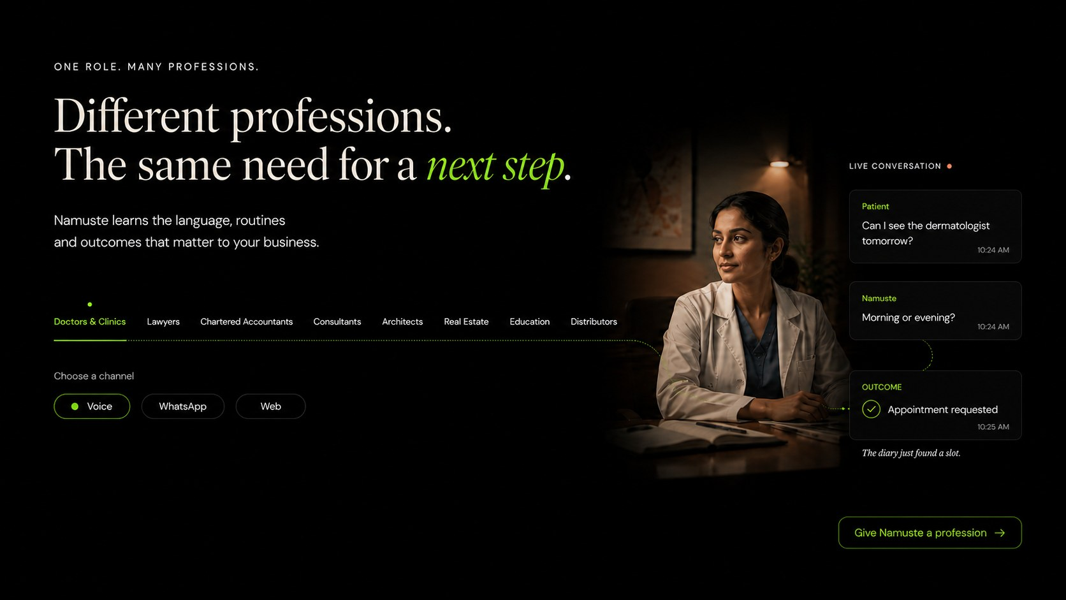
Doctors & Clinics selected state. Rebuild responsively; do not ship the screenshot as a webpage section.
Reference field | Implementation direction
Selected state | Doctors & Clinics
Conversation scenario | Patient appointment request
Outcome | Appointment requested
Channels | Voice default; WhatsApp and Web available where supported.
Interaction | Selected label in lime; inactive labels in ivory; selected state updates image, dialogue, outcome and CTA.
Route behaviour | Stable fragment/deep link; CTA opens the relevant dedicated page or preserves selected context in the demonstration.
REFERENCE STATUS Compliant reference: selected profession and Voice/WhatsApp/Web chooser appear together.

PVR-02 / PROFESSION VISUAL REFERENCE

Lawyers
Directional desktop reference for the selected profession state.
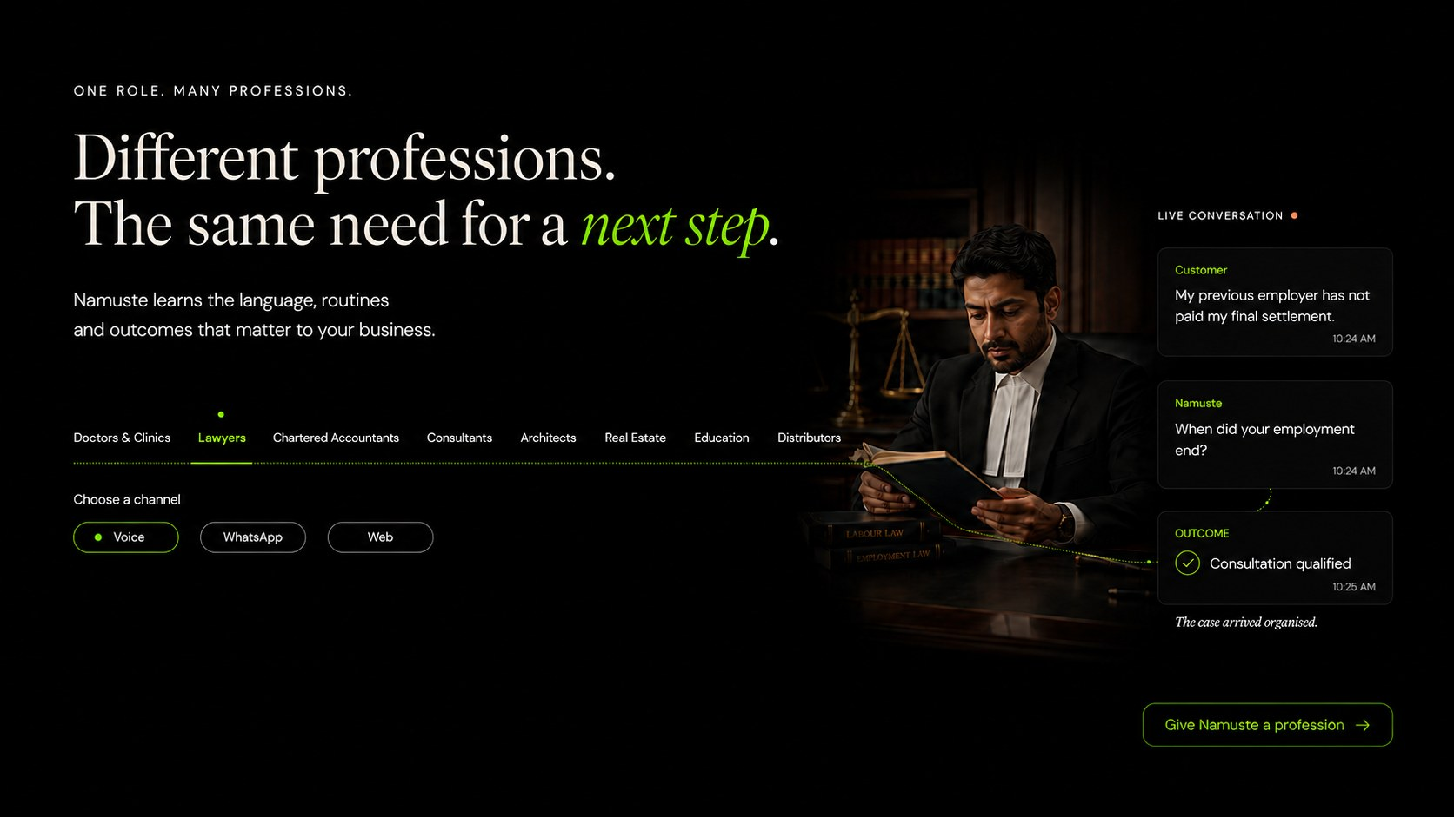
Lawyers selected state. Rebuild responsively; do not ship the screenshot as a webpage section.
Reference field | Implementation direction
Selected state | Lawyers
Conversation scenario | Employment matter intake
Outcome | Consultation qualified
Channels | Voice default; WhatsApp and Web available where supported.
Interaction | Selected label in lime; inactive labels in ivory; selected state updates image, dialogue, outcome and CTA.
Route behaviour | Stable fragment/deep link; CTA opens the relevant dedicated page or preserves selected context in the demonstration.
REFERENCE STATUS Compliant reference: selected profession and channel chooser appear together.

PVR-03 / PROFESSION VISUAL REFERENCE

Chartered Accountants
Directional desktop reference for the selected profession state.
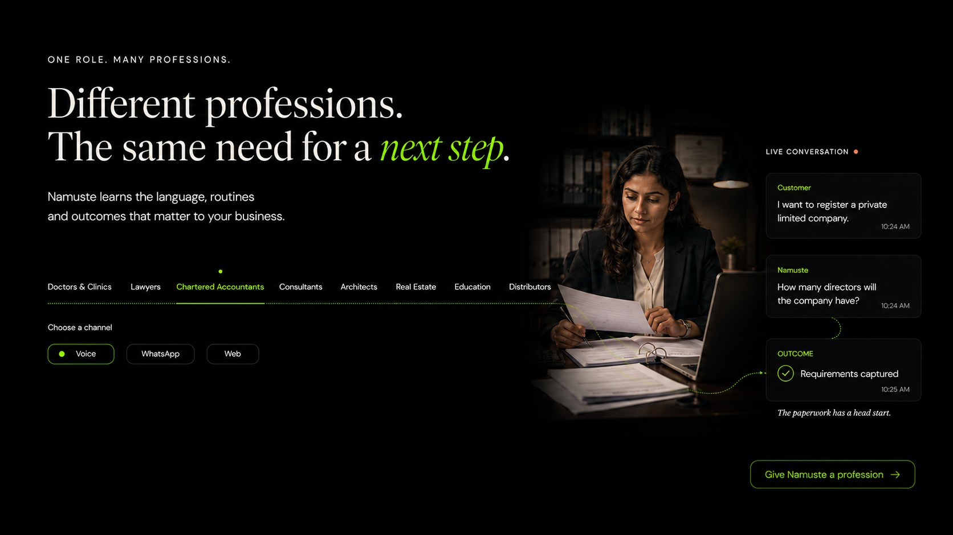
Chartered Accountants selected state. Rebuild responsively; do not ship the screenshot as a webpage section.
Reference field | Implementation direction
Selected state | Chartered Accountants
Conversation scenario | Private limited company registration enquiry
Outcome | Requirements captured
Channels | Voice default; WhatsApp and Web available where supported.
Interaction | Selected label in lime; inactive labels in ivory; selected state updates image, dialogue, outcome and CTA.
Route behaviour | Stable fragment/deep link; CTA opens the relevant dedicated page or preserves selected context in the demonstration.
REFERENCE STATUS Compliant reference: selected profession and channel chooser appear together.

PVR-04 / PROFESSION VISUAL REFERENCE

Consultants
Directional desktop reference for the selected profession state.
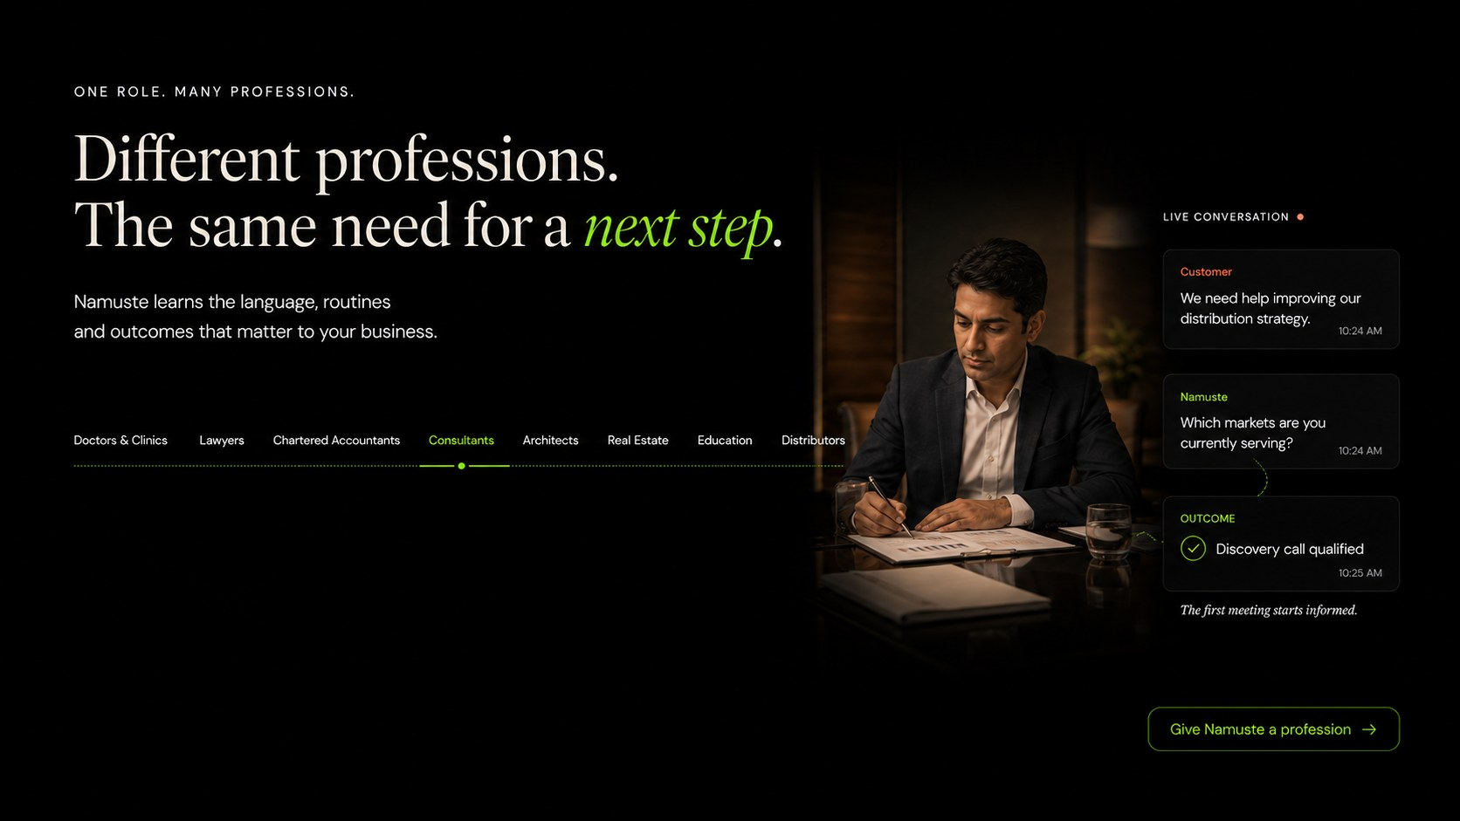
Consultants selected state. Rebuild responsively; do not ship the screenshot as a webpage section.
Reference field | Implementation direction
Selected state | Consultants
Conversation scenario | Distribution strategy discovery
Outcome | Discovery call qualified
Channels | Voice default; WhatsApp and Web available where supported.
Interaction | Selected label in lime; inactive labels in ivory; selected state updates image, dialogue, outcome and CTA.
Route behaviour | Stable fragment/deep link; CTA opens the relevant dedicated page or preserves selected context in the demonstration.
REFERENCE STATUS Art-direction reference. Production implementation must add “Choose a channel” directly beneath the selected profession.

PVR-05 / PROFESSION VISUAL REFERENCE

Architects
Directional desktop reference for the selected profession state.
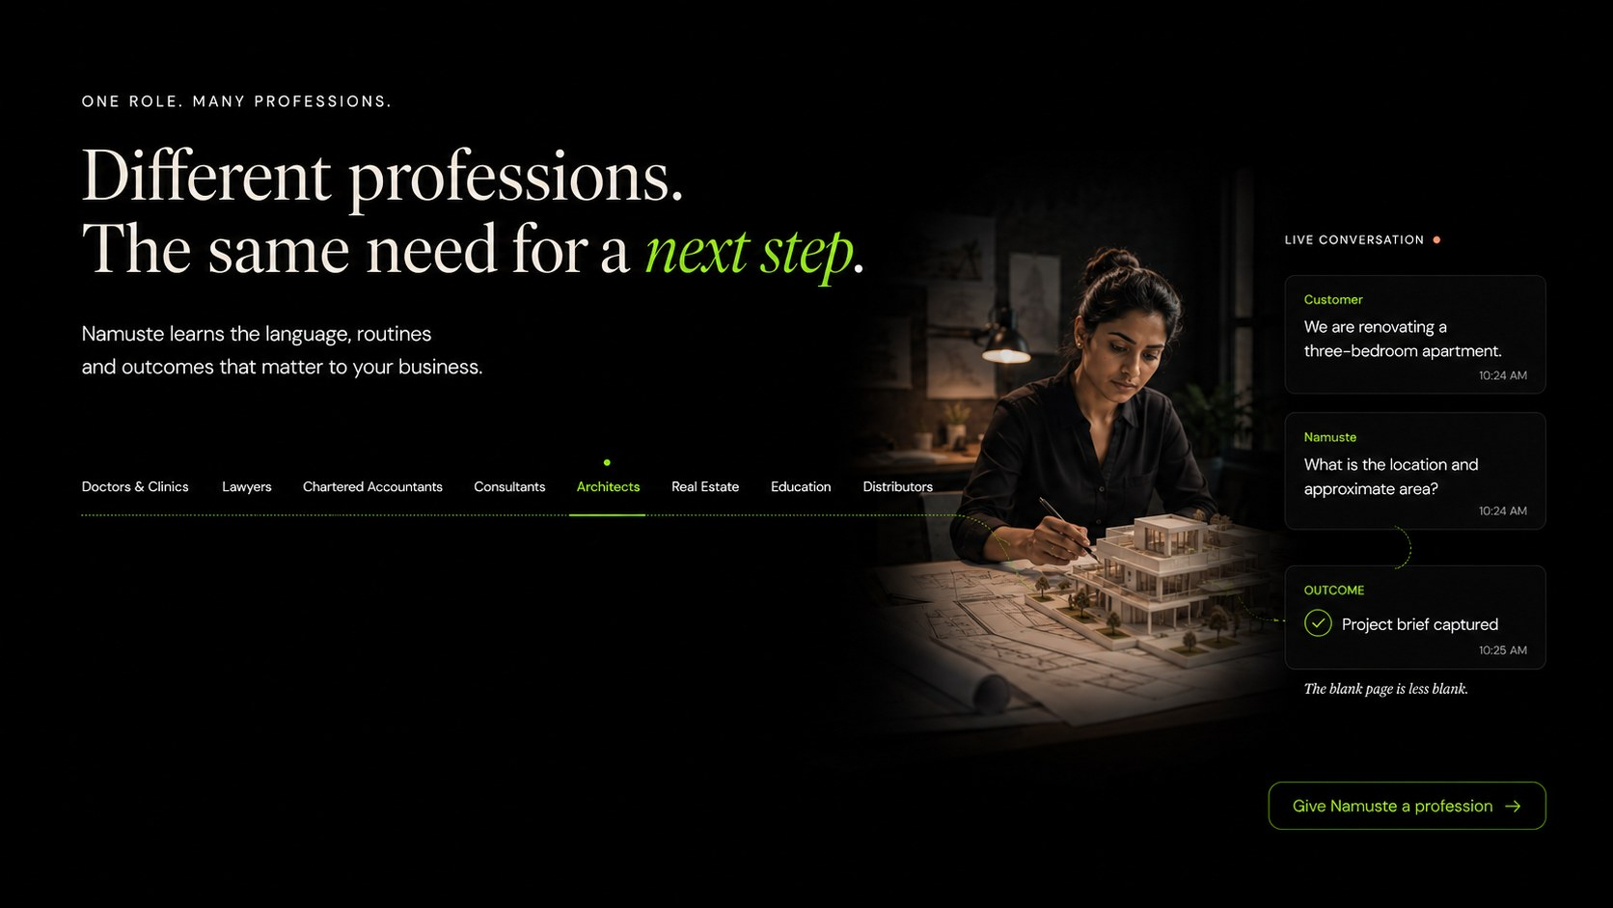
Architects selected state. Rebuild responsively; do not ship the screenshot as a webpage section.
Reference field | Implementation direction
Selected state | Architects
Conversation scenario | Residential renovation brief
Outcome | Project brief captured
Channels | Voice default; WhatsApp and Web available where supported.
Interaction | Selected label in lime; inactive labels in ivory; selected state updates image, dialogue, outcome and CTA.
Route behaviour | Stable fragment/deep link; CTA opens the relevant dedicated page or preserves selected context in the demonstration.
REFERENCE STATUS Art-direction reference. Production implementation must add “Choose a channel” directly beneath the selected profession.

PVR-06 / PROFESSION VISUAL REFERENCE

Real Estate
Directional desktop reference for the selected profession state.
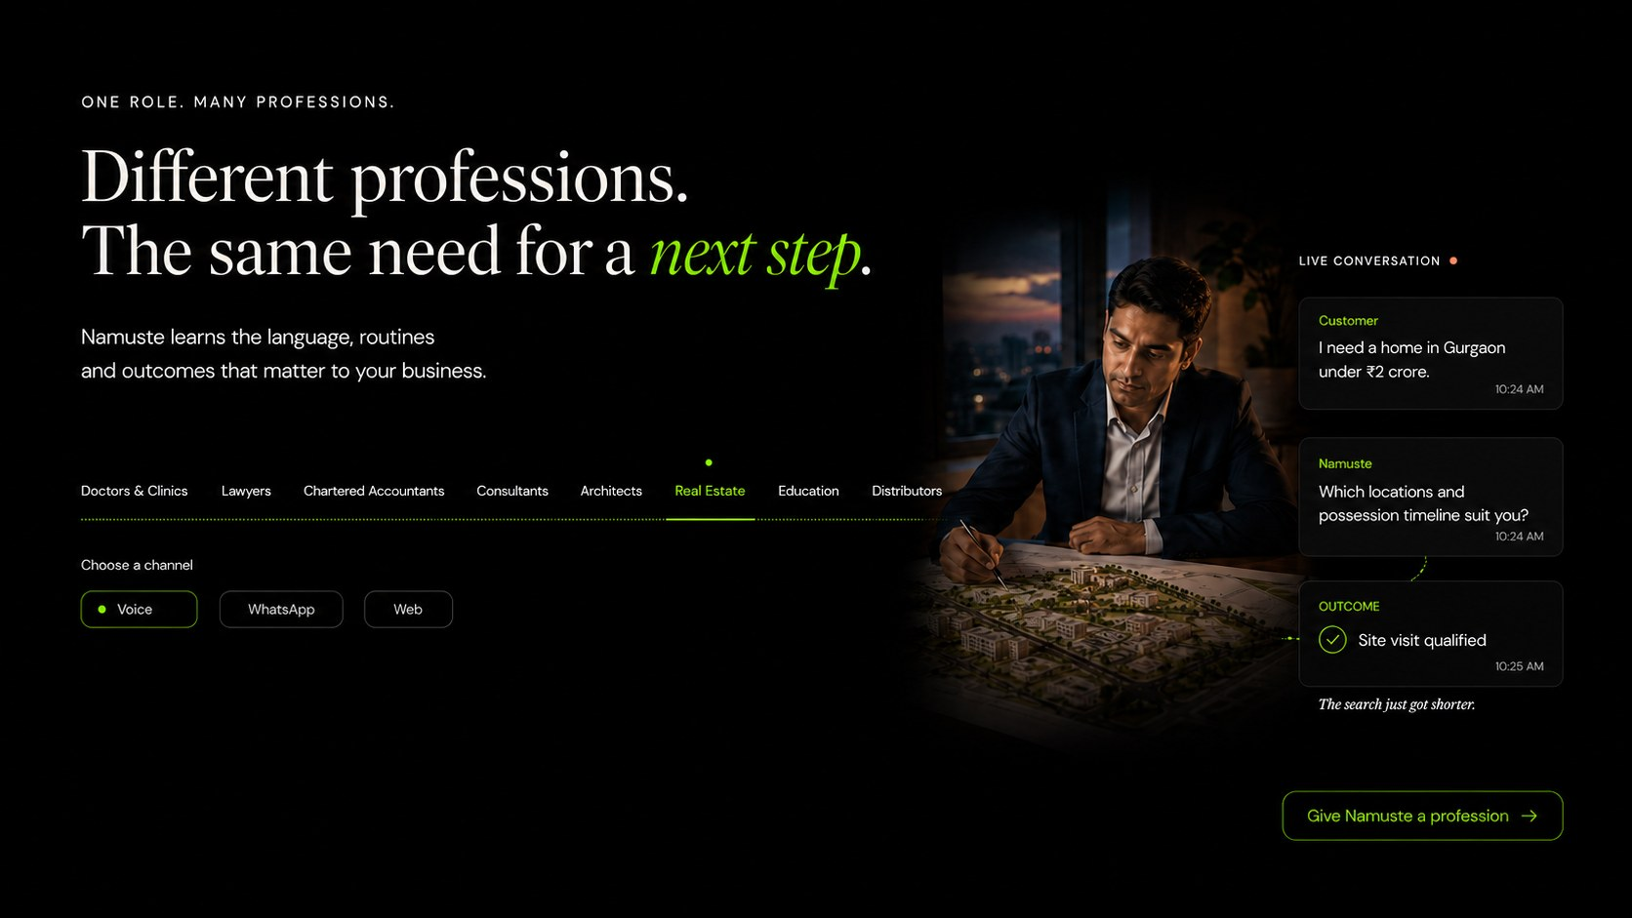
Real Estate selected state. Rebuild responsively; do not ship the screenshot as a webpage section.
Reference field | Implementation direction
Selected state | Real Estate
Conversation scenario | Property requirement and location qualification
Outcome | Site visit qualified
Channels | Voice default; WhatsApp and Web available where supported.
Interaction | Selected label in lime; inactive labels in ivory; selected state updates image, dialogue, outcome and CTA.
Route behaviour | Stable fragment/deep link; CTA opens the relevant dedicated page or preserves selected context in the demonstration.
REFERENCE STATUS Compliant reference: selected profession and channel chooser appear together.

PVR-07 / PROFESSION VISUAL REFERENCE

Education
Directional desktop reference for the selected profession state.
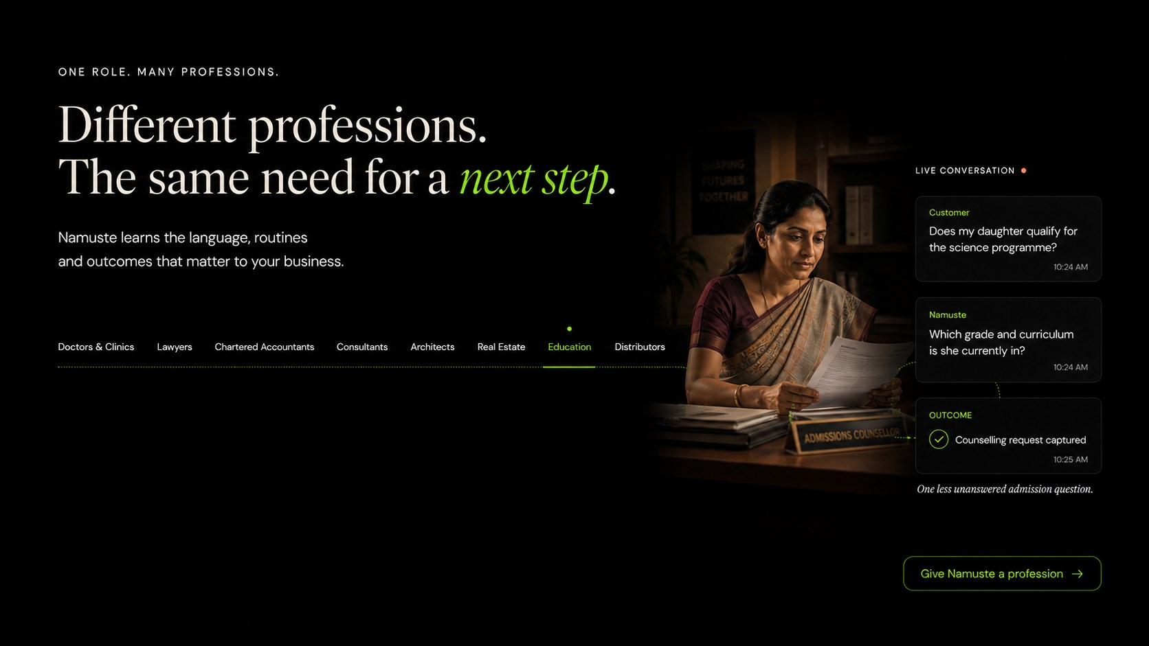
Education selected state. Rebuild responsively; do not ship the screenshot as a webpage section.
Reference field | Implementation direction
Selected state | Education
Conversation scenario | Programme eligibility enquiry
Outcome | Counselling request captured
Channels | Voice default; WhatsApp and Web available where supported.
Interaction | Selected label in lime; inactive labels in ivory; selected state updates image, dialogue, outcome and CTA.
Route behaviour | Stable fragment/deep link; CTA opens the relevant dedicated page or preserves selected context in the demonstration.
REFERENCE STATUS Art-direction reference. Production implementation must add “Choose a channel” directly beneath the selected profession.

PVR-08 / PROFESSION VISUAL REFERENCE

Distributors
Directional desktop reference for the selected profession state.
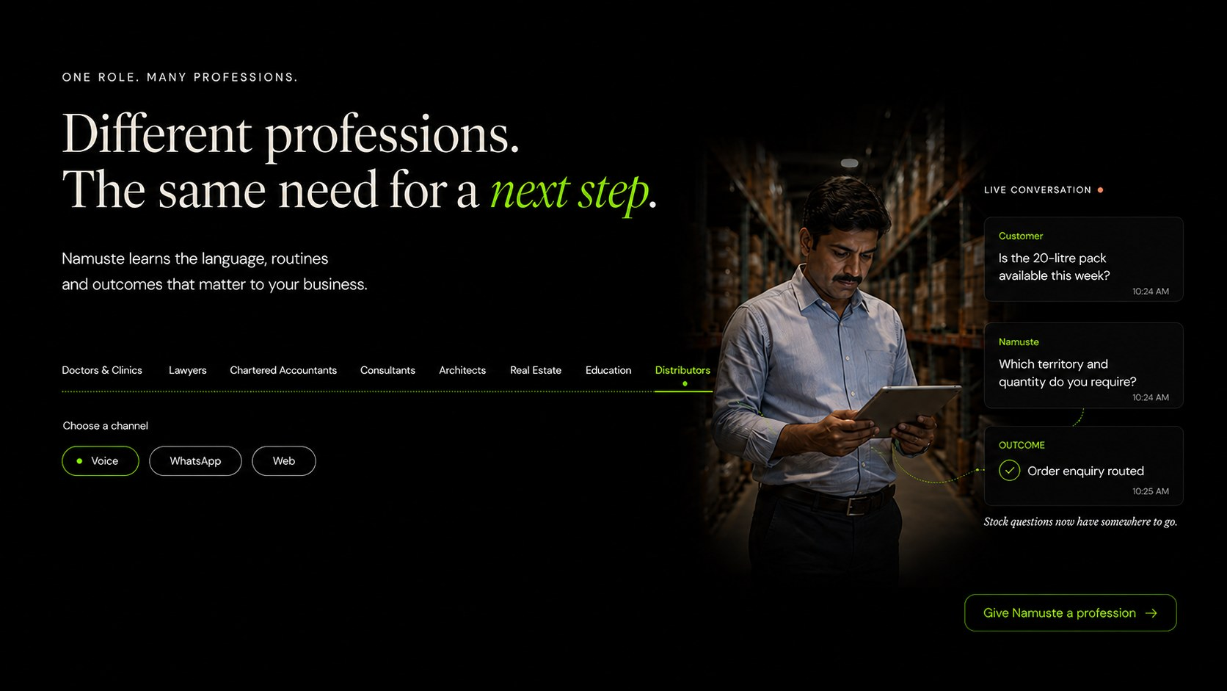
Distributors selected state. Rebuild responsively; do not ship the screenshot as a webpage section.
Reference field | Implementation direction
Selected state | Distributors
Conversation scenario | Stock, territory and quantity enquiry
Outcome | Order enquiry routed
Channels | Voice default; WhatsApp and Web available where supported.
Interaction | Selected label in lime; inactive labels in ivory; selected state updates image, dialogue, outcome and CTA.
Route behaviour | Stable fragment/deep link; CTA opens the relevant dedicated page or preserves selected context in the demonstration.
REFERENCE STATUS Compliant reference: selected profession and channel chooser appear together.

APPENDIX D

Enterprise-wise visual references
These eight screens are the directional references for the enterprise explorer and dedicated enterprise routes. Each state must add organisational topology—location, department, routing, escalation and ownership—rather than merely changing the photograph.
NON-NEGOTIABLE LAYOUT RULE Every selected enterprise must reveal “Choose a channel” immediately beneath the enterprise selector. The selected enterprise and channel jointly update one conversation journey.

EVR-01 / ENTERPRISE VISUAL REFERENCE

Healthcare Networks
Directional desktop reference for the selected enterprise state.
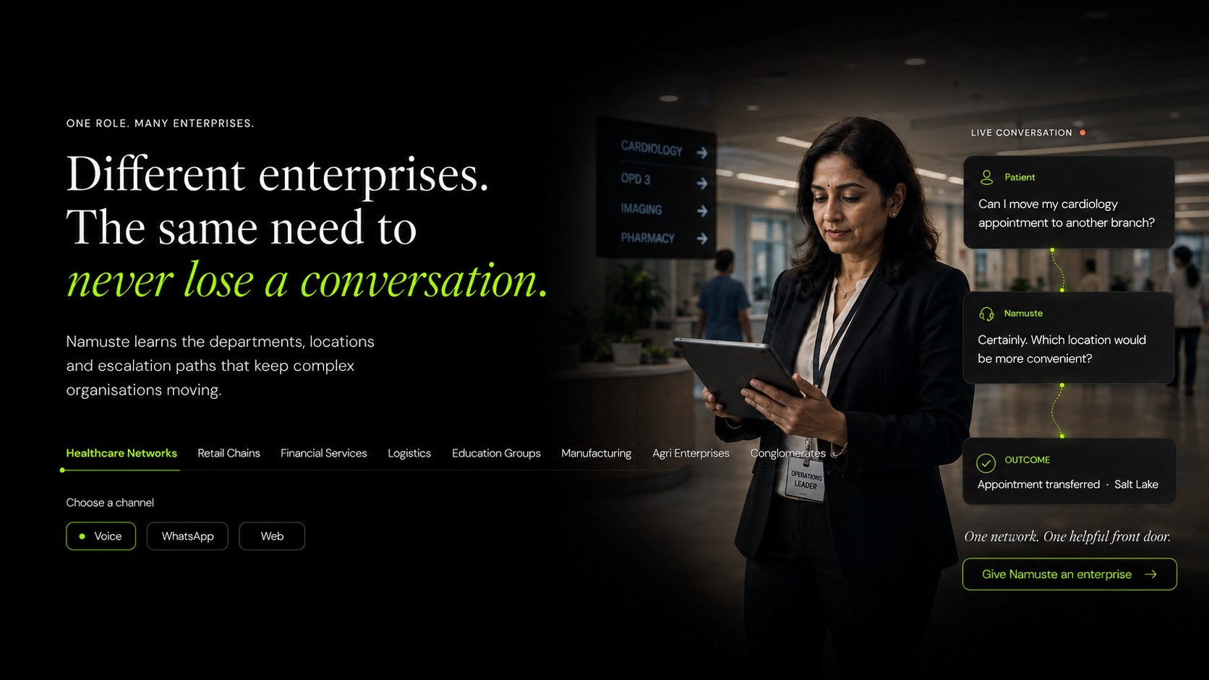
Healthcare Networks selected state. Rebuild responsively; do not ship the screenshot as a webpage section.
Reference field | Implementation direction
Selected state | Healthcare Networks
Conversation scenario | Cross-location cardiology appointment
Outcome | Appointment transferred to preferred branch
Channels | Voice default; WhatsApp and Web available where supported.
Interaction | Selected label in lime; inactive labels in ivory; selected state updates image, dialogue, outcome and CTA.
Route behaviour | Stable fragment/deep link; CTA opens the relevant dedicated page or preserves selected context in the demonstration.
REFERENCE STATUS Healthcare Networks remains the first enterprise state, not the only enterprise story.

EVR-02 / ENTERPRISE VISUAL REFERENCE

Retail Chains
Directional desktop reference for the selected enterprise state.
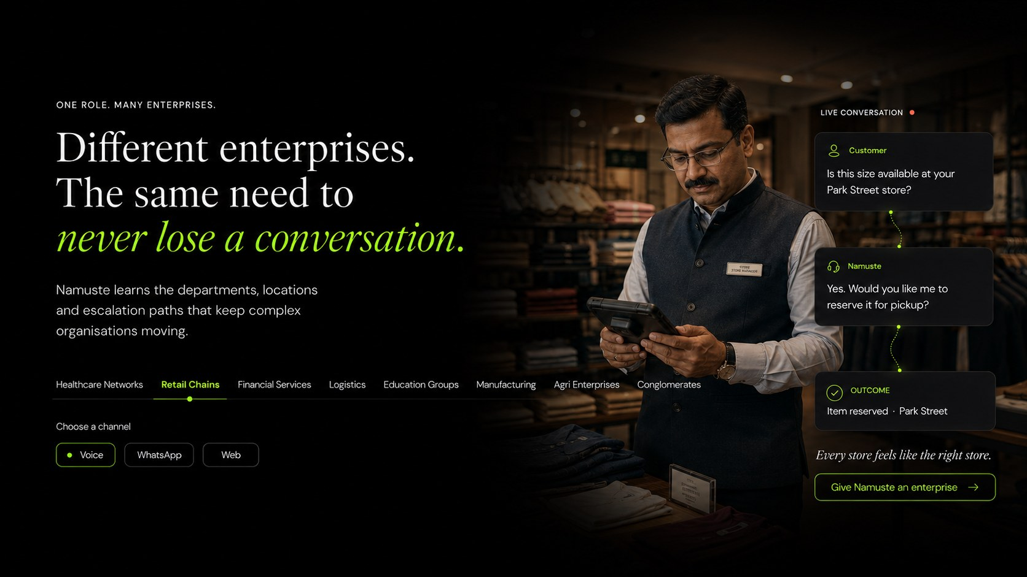
Retail Chains selected state. Rebuild responsively; do not ship the screenshot as a webpage section.
Reference field | Implementation direction
Selected state | Retail Chains
Conversation scenario | Store-level product availability and reservation
Outcome | Item reserved at selected store
Channels | Voice default; WhatsApp and Web available where supported.
Interaction | Selected label in lime; inactive labels in ivory; selected state updates image, dialogue, outcome and CTA.
Route behaviour | Stable fragment/deep link; CTA opens the relevant dedicated page or preserves selected context in the demonstration.
REFERENCE STATUS Reference must preserve store, location and inventory context.

EVR-03 / ENTERPRISE VISUAL REFERENCE

Financial Services
Directional desktop reference for the selected enterprise state.
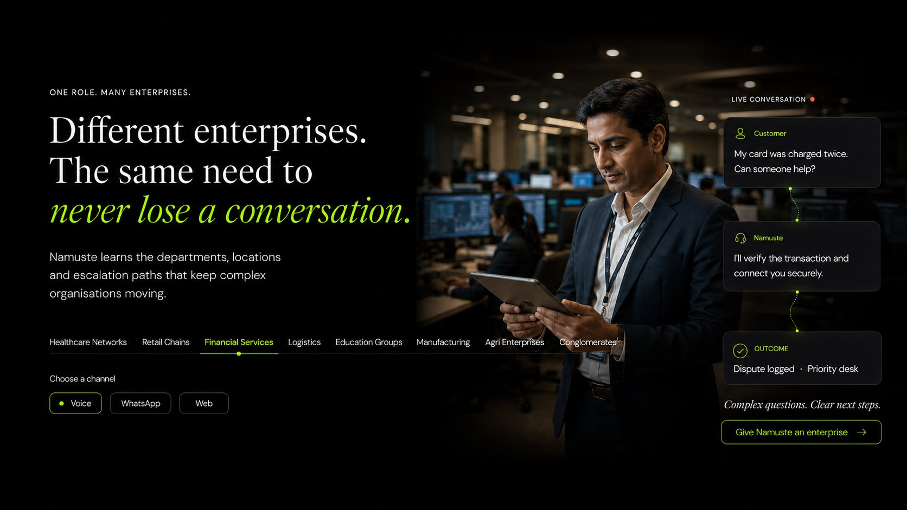
Financial Services selected state. Rebuild responsively; do not ship the screenshot as a webpage section.
Reference field | Implementation direction
Selected state | Financial Services
Conversation scenario | Duplicate charge and secure escalation
Outcome | Dispute logged to priority desk
Channels | Voice default; WhatsApp and Web available where supported.
Interaction | Selected label in lime; inactive labels in ivory; selected state updates image, dialogue, outcome and CTA.
Route behaviour | Stable fragment/deep link; CTA opens the relevant dedicated page or preserves selected context in the demonstration.
REFERENCE STATUS Do not imply financial advice; show verification, consent and controlled handoff.

EVR-04 / ENTERPRISE VISUAL REFERENCE

Logistics
Directional desktop reference for the selected enterprise state.
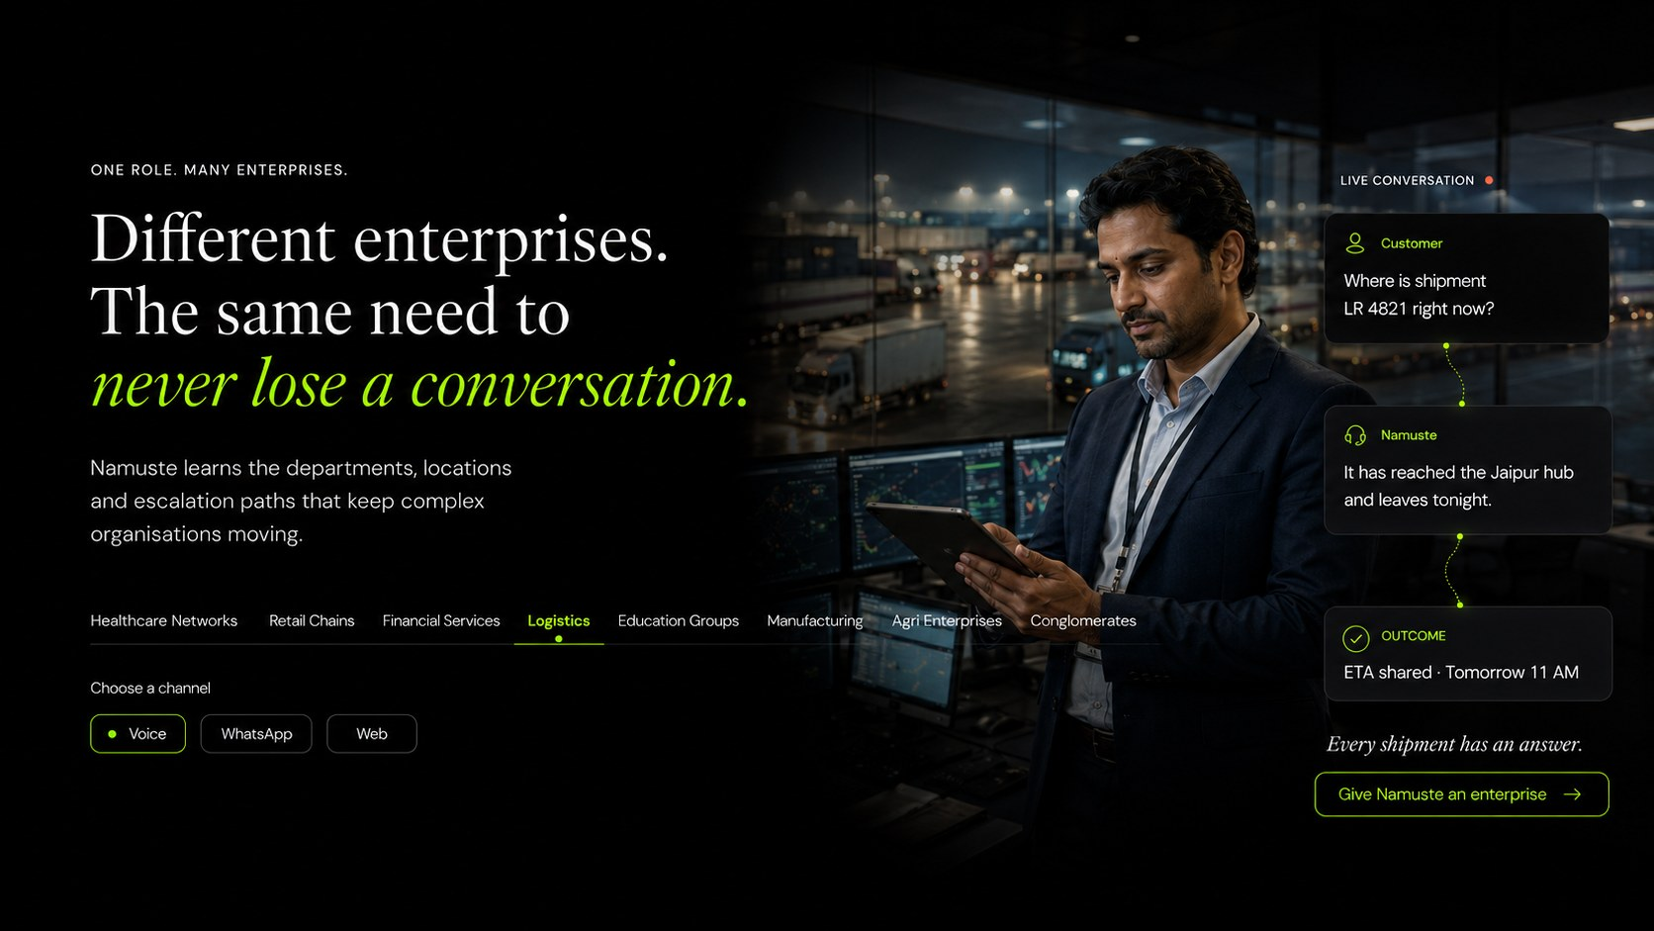
Logistics selected state. Rebuild responsively; do not ship the screenshot as a webpage section.
Reference field | Implementation direction
Selected state | Logistics
Conversation scenario | Shipment status and hub update
Outcome | ETA shared
Channels | Voice default; WhatsApp and Web available where supported.
Interaction | Selected label in lime; inactive labels in ivory; selected state updates image, dialogue, outcome and CTA.
Route behaviour | Stable fragment/deep link; CTA opens the relevant dedicated page or preserves selected context in the demonstration.
REFERENCE STATUS Reference must show shipment, hub, exception and promised update context.

EVR-05 / ENTERPRISE VISUAL REFERENCE

Education Groups
Directional desktop reference for the selected enterprise state.
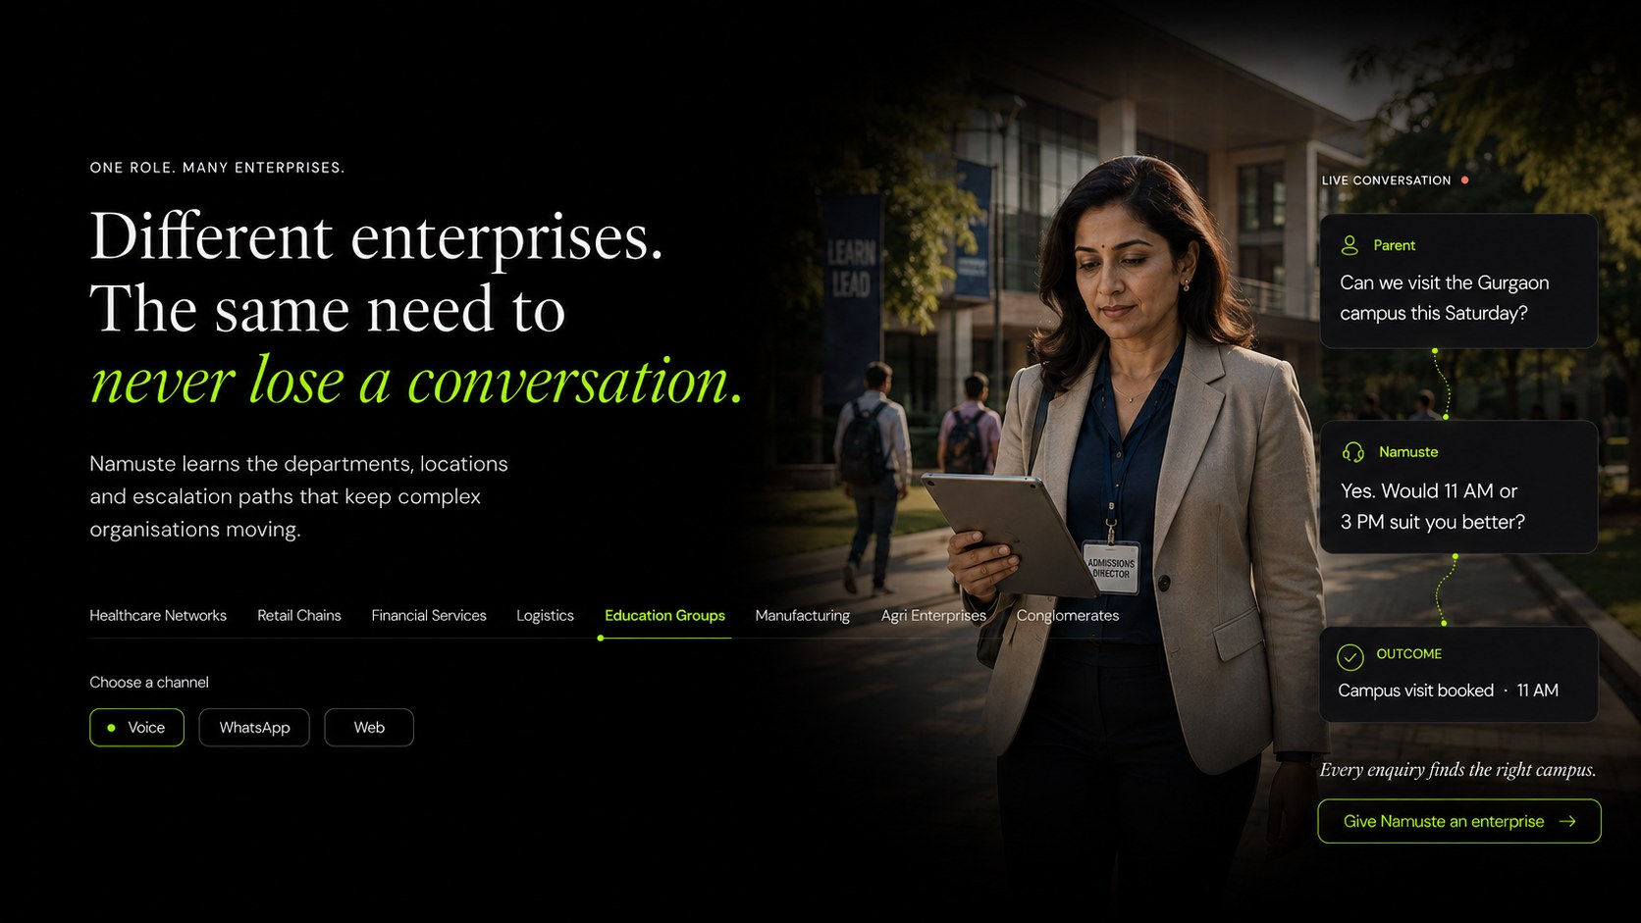
Education Groups selected state. Rebuild responsively; do not ship the screenshot as a webpage section.
Reference field | Implementation direction
Selected state | Education Groups
Conversation scenario | Campus visit enquiry
Outcome | Campus visit booked
Channels | Voice default; WhatsApp and Web available where supported.
Interaction | Selected label in lime; inactive labels in ivory; selected state updates image, dialogue, outcome and CTA.
Route behaviour | Stable fragment/deep link; CTA opens the relevant dedicated page or preserves selected context in the demonstration.
REFERENCE STATUS Reference must preserve campus, city, programme and counsellor routing.

EVR-06 / ENTERPRISE VISUAL REFERENCE

Manufacturing
Directional desktop reference for the selected enterprise state.
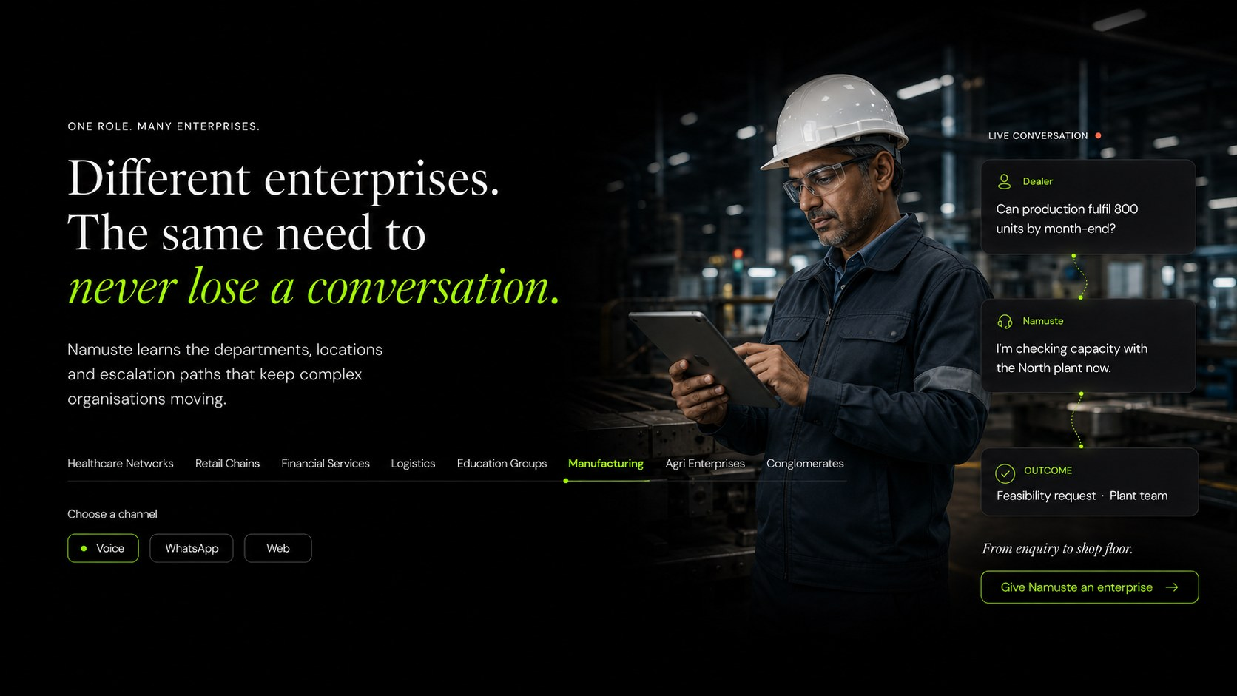
Manufacturing selected state. Rebuild responsively; do not ship the screenshot as a webpage section.
Reference field | Implementation direction
Selected state | Manufacturing
Conversation scenario | Dealer production-capacity enquiry
Outcome | Feasibility request routed to plant team
Channels | Voice default; WhatsApp and Web available where supported.
Interaction | Selected label in lime; inactive labels in ivory; selected state updates image, dialogue, outcome and CTA.
Route behaviour | Stable fragment/deep link; CTA opens the relevant dedicated page or preserves selected context in the demonstration.
REFERENCE STATUS Reference must show plant/capacity ownership rather than a generic lead response.

EVR-07 / ENTERPRISE VISUAL REFERENCE

Agri Enterprises
Directional desktop reference for the selected enterprise state.
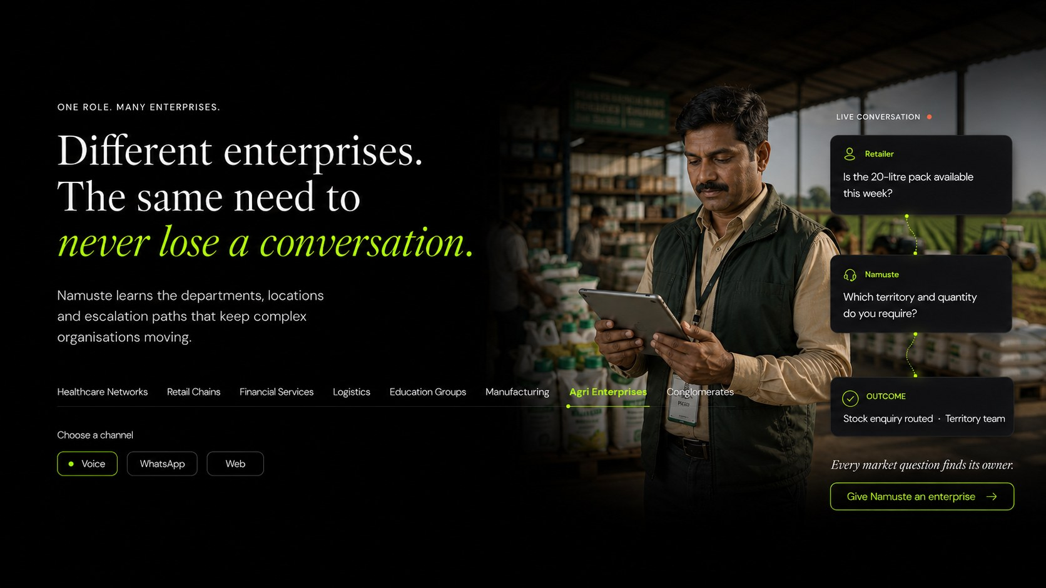
Agri Enterprises selected state. Rebuild responsively; do not ship the screenshot as a webpage section.
Reference field | Implementation direction
Selected state | Agri Enterprises
Conversation scenario | Product and availability enquiry across field commerce
Outcome | Approved next step routed to the relevant team
Channels | Voice default; WhatsApp and Web available where supported.
Interaction | Selected label in lime; inactive labels in ivory; selected state updates image, dialogue, outcome and CTA.
Route behaviour | Stable fragment/deep link; CTA opens the relevant dedicated page or preserves selected context in the demonstration.
REFERENCE STATUS Use as visual-direction reference; production copy must be verified for the chosen agri journey.

EVR-08 / ENTERPRISE VISUAL REFERENCE

Conglomerates
Directional desktop reference for the selected enterprise state.
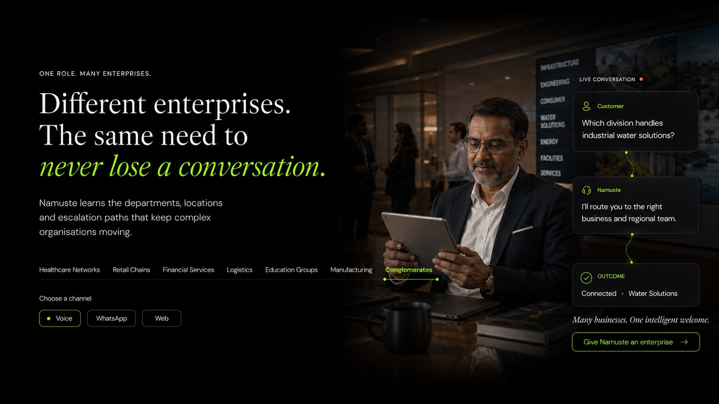
Conglomerates selected state. Rebuild responsively; do not ship the screenshot as a webpage section.
Reference field | Implementation direction
Selected state | Conglomerates
Conversation scenario | Business-unit and regional routing
Outcome | Connected to the correct operating company
Channels | Voice default; WhatsApp and Web available where supported.
Interaction | Selected label in lime; inactive labels in ivory; selected state updates image, dialogue, outcome and CTA.
Route behaviour | Stable fragment/deep link; CTA opens the relevant dedicated page or preserves selected context in the demonstration.
REFERENCE STATUS Reference must demonstrate business unit, geography and department without exposing internal complexity.

APPENDIX E

Visual-state implementation checklist
Use this checklist when translating the reference screens into production components.
- Treat all sixteen screens as states of two reusable components: ProfessionExplorer and EnterpriseExplorer.
- Do not create sixteen separate hard-coded page sections or use screenshots as rendered website content.
- Preserve the approximately 70% negative-space discipline while adapting to available viewport width.
- Place “Choose a channel” directly beneath the selected profession or enterprise on desktop and mobile.
- Keep Voice selected by default unless capability configuration says otherwise; display WhatsApp and Web availability accurately.
- Update the cinematic environment, customer wording, Namuste response, outcome, boundary and CTA as one atomic state.
- Use correct tabs/ARIA semantics, keyboard arrows, visible focus and selected-state text in addition to colour.
- On mobile, stack selector → channel → conversation → outcome → CTA; never separate the selector and channel with unrelated content.
- Load responsive AVIF/WebP assets from CMS with focal-point crops; provide meaningful alt text and prevent layout shift.
- Track profession_select or enterprise_select together with channel_select and selected-state CTA events.
- Where an older art-direction reference omits the channel chooser, the production requirement—not the screenshot—controls the final layout.

